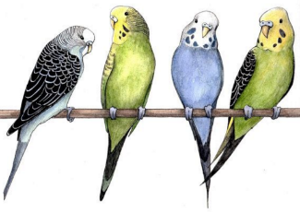
Group Research Log

Scientists: (1)

(2)

(3)
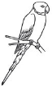
Directions: The research log is a vital for project flow and creating an effective product. Each group member has a specific number, either (1), (2), or (3). Individual student work will be added only under your specific scientist number. Part of your grade will be from how much good information and research you have done, this is identified by your scientist number. This can be in the form of photos, links to keen YouTube videos, or information typed from a particular website.
Citations: Remember to put the following information after EACH different piece of information you add: (1) Author Last name, first initial, (2) name of website, (3) date of article, (4) date website was updated (at the bottom of the page), (5) URL. These 5 elements are needed for all entries into your research log because if you did not write it, you must cite it!!
SCIENTIFIC QUESTION: Type the scientific question that will guide your project below. If there is more than one question, number the questions separately (1, 2, 3, etc…)

Background Research - BEFORE YOU BUILD ANYTHING:
Directions: Using the scientist number you claimed above, add your research beneath the 7 questions below. REMEMBER to use the correct color for the text you add and type your number, in parentheses, after the text you add. ALL text added to answer these questions must be researched and cannot not be your opinion (that will lose you points). Questions must be answered in detail and each student must provide information to each question so they become mini-experts on the topic by the end of the background research phase. *ANSWERED INDIVIDUALLY* EACH MEMBER CONTRIBUTES!
1. Define the following types of nests in detail: cavity, cup, platform, pendulum, and spherical. Each group member should provide at least one photo of a bird that builds each nest, so you should have THREE different examples of each nest type.
2. Research two species of bird per group member and list the types of material they use to construct their nest. REMEMBER: there are different materials used in different locations within the nest so indicate where this difference in material is.

3. What major category of nest does your chosen bird build?

4. What materials are used and what process does the bird use to construct the nest? This may take a good deal of research and video searches to find. The more information here, the better your over-all replica will be.

5. Where in the vertical forest layering does your bird construct their nest?

6. Sketch and write out detailed plans to build your nest replica (in essence, your intended procedure).

7. What is the purpose for a bird’s nest? Is there a characteristic shape that you are finding consistent between the five nest types you researched above?

8. In the “Where Do Birds Nest?” graphic above, differentiate between canopy, midstory, and understory. Then, from the diagram identify two birds that nest in each strata (or layer) of vegetation.

9. Which bird species are you planning on replicating? Provide this species’ COMMON NAME as well as its KINGDOM, PHYLUM, CLASS, ORDER, FAMILY, GENUS, & SPECIES classifications. A photo of the nest you are replicating and photos of the bird perching and in flight.

10. What are the major characteristics of the bird species you’ve chosen? Clutch size, incubation period, bird size and weight, food preferences, seasonal location and migration pattern?

HYPOTHESIS: After generating significant background research on your bird species and how they construct their nest, type the hypothesis that you will test below. If there is more than one hypothesis, number them separately (1, 2, 3, etc…)

procedure: This is where you type your proposed methodology, or procedures that you are attempting to use to build your functional replica of the nest for this project. You can type the steps numerically (1, 2, 3…etc) or show the build in phases (Phase I – Mount Substrate, Phase II – Nest Base, Phase III…etc) in the order that you will conduct these groups of steps. Include the roles each group member plays and where they are responsible for specific tasks. This is up to you, BUT you MUST have a plan documented before you come to Mr. F for approval.

This Research Log MUST BE APPROVED BY MR. F BEFORE MOVING ON TO THE BUILD.
Where do birds nest?
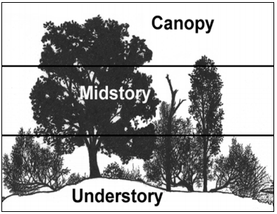
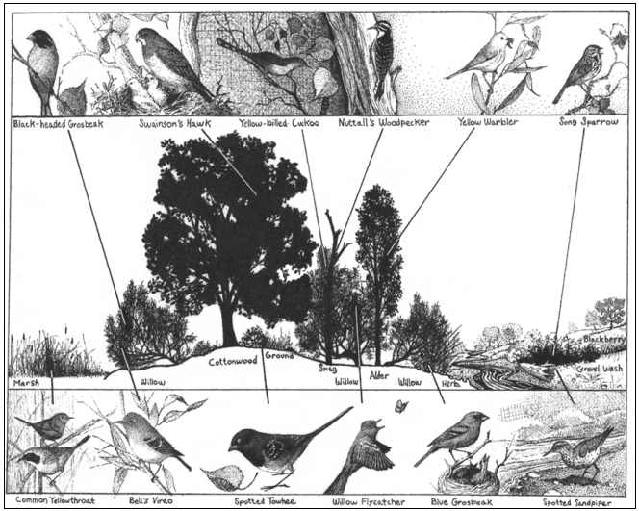
Birds nest from directly on the ground to the tops of trees in one of the three main vegetation layers: understory (shrubby, weedy undergrowth beneath trees), mid-story (includes shorter trees and taller shrubs), and canopy (includes the tops of trees).

“The Build” Notes – da’ data:
Directions: There is a reason for conducting such extensive background research. As you follow your proposed methods, this is where you will start making notes about the successes and failures in finding an answer to your original scientific question. Be detailed and have each member contribute. If you want to have one member be the designated notes recorder at a time, then rotate, that would be a great idea so you will have all the qualitative and quantitative data recorded for your final research paper. You can also include time-lapse photos from the same height and angle of your nest as it is built so you can describe events in the sequence that they occur.

Analysis questions: To be included in your research paper’s conclusion. *ANSWERED INDIVIDUALLY*

1. What was the PURPOSE of your group’s build?

2. What is the science behind this challenge?

3. Did the data recorded on the build support or reject your HYPOTHESIS? Explain.

4. What were the MAJOR RESULTS you observed during this challenge? How did this data relate to your scientific question and hypothesis?

5. What was your group most successful with? Explain why.

6. What was the most challenging part of this nest building challenge? Explain why.

7. How well was your nest constructed? Did it hold the three eggs and meet the requirements for the challenge? How could your chosen method or product be IMPROVED? There’s always room for improvement…

8. What did you learn about construction and engineering during this challenge?

9. Explain how you used the scientific method AND the engineering/design process to accomplish your goal. BE DETAILED HERE.

Rubrics:
The challenge has a total of 50 points. 40 points are due to the 4 parameters below and 10 points are your participation and effort grade based on observations and student group rating sheet we conduct after the project is over. The four aspects of the project are: (1) A detailed research log complete with proper citations (one per group), (2) a functional nest replica that can support three large marbles (one per group), (3) a species identification card (one per group), and (4) a research report (one per student).
Product | Beyond Expectation (10) | Meets Expectation (7-9) | Below Expectation (1-6) | Total Points
(1) Research Log | Comprehensive and very well researched. Shows students have become experts on the topics in question. Perfect citations. | Shows adequate research but lacking the in depth detail to be a 10. Some citations missing. | Effort is lacking. Depth of research is not the level that this course requires. No citations.
(2) Nest Replica | Nest replica holds the 3 eggs easily, is very sturdy in its construction, and can easily be seen as being made by the species it was made to represent. Materials are only those researched to be used by the chosen bird engineer and is the perfect size for the bird. | Nest replica holds the 3 eggs. Not sturdy on the limb which can fail over time. Representation of nest is either too small/large for the species chosen. | Nest replica is not able to hold the 3 eggs or does not remain intact. Does not resemble the nest built by the chosen species and size is not near the dimensions required for the bird. Faulty research evident.
(3) Species Identification Card | Card contains well researched information on the bird:  -Common name  -Scientific name  -Bird measurements & wt.  -Diet  -Clutch size  -Geographic location  -Migration range(s)  -Type of nest  -Nest dimensions  -Nest material  -Where nest is built  -Incubation period | Card contains adequately researched information but lacks detail. Missing 1-2 parameters noted in a beyond expectation score | Card contains a weak amount of information that represents a less than adequate effort. Missing 3+ parameters noted in the beyond expectation score.
(4) Research Report | Perfectly formatted scientific purpose, question, and hypothesis. Contains detailed procedures that are either noted by step numbers or detailed in phases with explanations. Data collected is well organized and speaks directly to the hypothesis. The conclusion goes into detail using the analysis questions provided. Research report is 4+ pages. | Formatting of purpose, question, or hypothesis has errors. Procedures not adequately documented to give a clear picture of steps taken or phases chosen. Data representation is not clear or professional. Conclusion is too brief to be considered beyond expectation. Research report is 2-3 pages. | Purpose, question, and hypothesis are incorrectly formatted or missing. Data representation is weak and does not give a clear picture of what occurred during the build. Conclusions are incomplete or largely missing. Shows an apparent lack of effort for what the project demanded.
Total points |  |  |  | /40

