Brine Shrimp Salinity Tolerance Lab – All questions to be numbered and completed in a Google doc/MS Word file and shared with Mr. F (Lucas.Fatsy@naugatuck.k12.ct.us)
1) State the problem or question this experiment investigates.
2) What was your hypothesis to this phenomena?
3) Why is it important for all lab groups to leave their “micro-environments” in the same location for the entire testing period? Use the concept of “variable” to explain your response.
4) Did your group encounter any difficulties counting the brine shrimp in the samples? If so, how were you able to resolve them?
5) Describe the unique life cycle of the brine shrimp. What is so “unique” about it?
6) Provide the scientific name of the brine shrimp and categorize it into a kingdom, phylum, class, order, family, genus, and species.
7) Summarize the results of your experiment using the class data while comparing it to your individual group data.
8) Did the class data support your hypothesis? Explain.
9) Based on the results of your experiment, which solution was the best in which to hatch brine shrimp eggs? Explain your answer. You may use the articles and information on the pages of the class website and/or a web search.
10) Design another experiment to measure the tolerance of brine shrimp to a different environmental variable such as light, temperature, pH, etc. Describe it here.
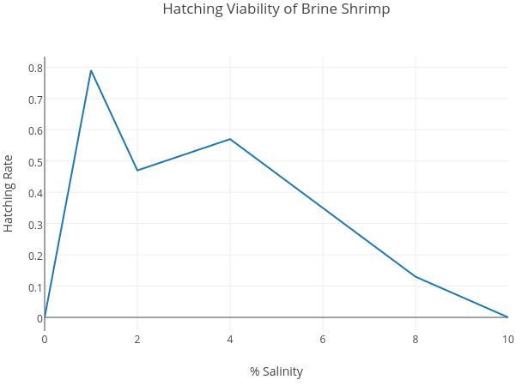
11) Below you will find a previous graph done over a 2 day period. Compare and contrast your data set with this one and determine the validity of your class’ data versus a previous class of Mr. F.
12) What are the reasons that brine shrimp are able to tolerate such a vast extreme of salinity conditions?
13) Explain at least one other geographic location where brine shrimp salinity tolerance was tested and compare our results with those results. What were the similarities? Differences?

