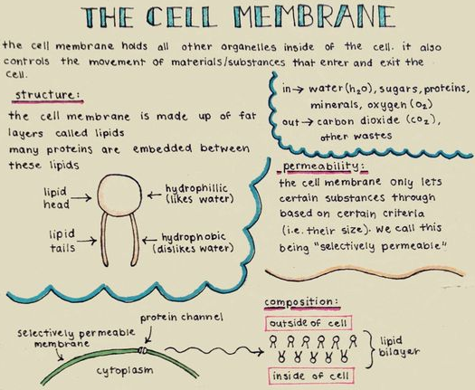
NAME: ____________________

Key Terms:
Plasma membrane homeostasis
phospholipid bilayer hydrophilic head Hydrophobic tail fatty acid cholesterol semi-permeable
Selectively permeable
carbohydrate ion
polar/nonpolar Channel protein simple diffusion facilitated diffusion
Concentration gradient
passive diffusion active transport carrier proteins ATP
glycoproteins immune system
PART ONE: Model Analysis.
Directions: Observe what is going on in the diagrams and fill in the table with your assessments.
Simple Diffusion (Passive) – non-carrier mediated diffusion
Along which concentration gradient do the molecules move (from low to high or from high to low concentration)
Which molecules can cross the membrane freely?
(water, glucose, polar, non-polar)
Which types of molecules are unable to cross the membrane freely? (water, glucose, polar, non-polar)
Are membrane transport proteins needed for these molecules to cross (yes/no)
Where in the body would you predict this might happen?

Osmosis
Along which concentration gradient do the molecules move (from low to high or from high to low concentration)
Which molecules can cross the membrane freely?
(water, glucose, polar, non-polar)
Types of solutions. Does water enter or leave or both the inside of the cell? | Diagram A:  Diagram B:  Diagram C:
How might this be different between animal and plant cells (you saw plant cells the other day!)
Where in the body would you predict this might happen? Why do you say this?

Passive Transport – Facilitated Diffusion
Along which concentration gradient do the molecules move (from low to high or from high to low concentration)
Which molecules can cross the membrane freely?
(water, glucose, polar, non-polar)
Are membrane transport proteins needed for these molecules to cross (yes/no). What types of membrane proteins are needed, if present?
What are examples of molecules that use a protein channel? Look at diagram…
What are examples of molecules that use a carrier protein? Again…diagram.
What unique set of steps do you see in the membrane proteins? Which protein does this and what do you observe about this action?

Where in the body might this take place? (Research)

Active Transport
Along which concentration gradient do the molecules move (from low to high or from high to low concentration)
Which molecules can cross the membrane freely?
(water, glucose, polar, non-polar)
Are membrane transport proteins needed for these molecules to cross (yes/no)
What new molecule is present during active transport? Where do you remember seeing this molecule this year?

What are the similarities/differences between the proteins in active transport vs. facilitated diffusion?

Where in the body would you predict this might happen?

PART TWO. Comparing Passive vs. Active Transport (video link here) or (webpage link here)
RULE: Active transport moves substances from an area of _______________ concentration to an area of _______________ concentration that requires the use of ___________ to do so.
Label the diagram below:
A: __________________________________ A1:_________________________________
A2: _________________________________ B: _________________________________
C: __________________________________ D: _________________________________
E: __________________________________ F: _________________________________
G: __________________________________ H: _________________________________
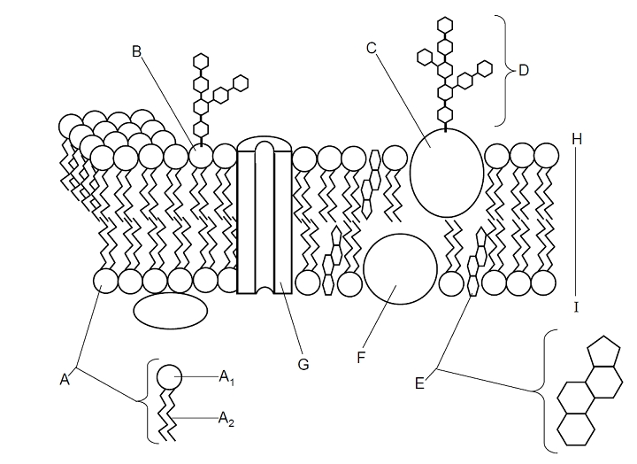
I: ___________________________________

PART THREE: Cell Defense: The Plasma Membrane Simulation (Link to simulation)
Directions: Read the steps here and all the information on the screen. Follow all the steps carefully filling in all the blanks.
Step 1: Use the link on the class website to go to the “Cell Defense” Simulation. You want to move to the “Choose Your Challenge!” menu. From the menu choose “Build a Membrane!” Dr. Vial has a vile weapon (note the play on words) that destroys plasma membranes. Without a ________________ ________________ cells of living things will die because they are unable to maintain _______________.
Step 2: Zoom in on the plasma membrane. From the “Urgent Message” you learn that phospholipids made up of a _________________________ head and two __________________________ tails.
The heads are _________________________ which means ______________________________.
The tails are __________________________ which means _______________________________.
The heads face out towards the ________________ and the tails facing ____________ _________.

Draw and label the phospholipid in the box:
Step 3: Repair the phospholipid membrane.
How many phospholipids did it take? _______
Step 4: What do you have to put into
the membrane to help stabilize it? ____________________________. How many did you add? _____
Step 5: What is another word for selectively permeable? ______________________________.
What does that mean? ____________________________________________________________ ____________________________________________________________________________
Step 6: What 2 molecules easily pass through the membrane? Record why for each.
Molecule 1 | Molecule 2

Step 7: What 3 molecules cannot easily pass through the membrane? Record why for each.
Molecule 1 | Molecule 2 | Molecule 3

What does polar mean? ___________________________________________________________ ____________________________________________________________________________
Step 8: Insert channel proteins into the membrane. Transport substances across the membrane. Note: You can only transport substances using channel proteins until there were ____________________________
_________________________________________________________________________________________. What is this process called? _____________________________
Step 9: Moving from _________ to __________ concentration requires the use of energy to _________ substances. This is called ______________________________ transport and uses: (place answer in table)
1. | 2.  Which is cell ______________

Step 10: Carbohydrates are like identification badges. Cells that have different membrane carbohydrates do different _______________________. The immune system uses the carbohydrates to _________________________ that your cells belong to __________________ and are not __________________________, __________________________, or other foreign cells.
What does the immune system do to foreign invaders? ________________________________
What kind of cell does this? ____________________________________
Step 11: Next take the “Membrane Structure Challenge!”
Step 12: Take the “Diffusion Challenge!”

Step 13: Take the “Energy and Transport Challenge!”
How many ATP did you use? ______ What type(s) of protein(s) were used? _________________
_________________________________Explain when each type was used. _____________
__________________________________________________________________________________________________________________________________________
Step 14: Take the “Osmosis Challenge!”
What is Osmosis? _________________________________________________________ _____________________________________________________________________
What is the name of the special proteins that let water pass through? ______________________
Is this passive or active transport? ______________________________________
Step 15: From your Scores Sheet record the following:
Lab Score (% correct): _______ Number Correct: _______ Number Incorrect: _______

Reflection:
The chemical that was responsible for the Chicago Tylenol murders we covered was _________________.
Discuss your thoughts on what type of molecule that was and why it was able to do so much harm to the 8 people who were murdered. ________________________________________________________ ________________________________________________________________________________________________________________________________________________________

