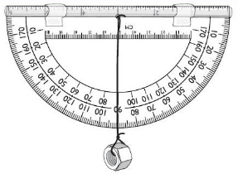
Name: ___________________________
Clinometer Warm-up Problem Set
Directions: You are challenged to tell the height of the following structures by your friend(s). Because you took Mr. F’s Applied Fluid Mechanics course and designed an amazing rocket to test, you say you can tell them with your eyes closed. Solve the problems below, drawing a picture to help you out.

1. A friend kicks a soccer ball in the air as hard as they can and bets you his new PS4 system that you can’ t tell the height. If you stand 75 feet away from him and at peak height, the ball has a 44 degree angular distance. Your’ eye is 4.5 feet from the ground, how high did your friend kick the ball?

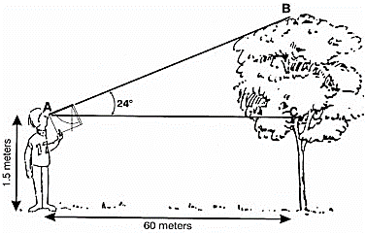
2. A friend finds the clinometer her father made and used back in high school. She thinks it’s silly and asks if you know what it is, or how it’s used. You tell her to look through the viewing tube to the top of the tree in the distance. Teach her how to do the math to find the height of point B, in the drawing.

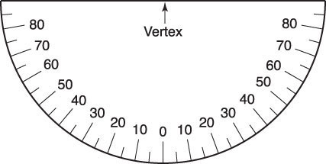
3. Standing 110 feet away from the class rocket launch pad and record the clinometer reading to the right when the rocket is at peak height. Your eye is 5 feet from the ground. Your classmate is certain that it went at least 90 feet or more. Should you contradict him? Do your math to prove it.

