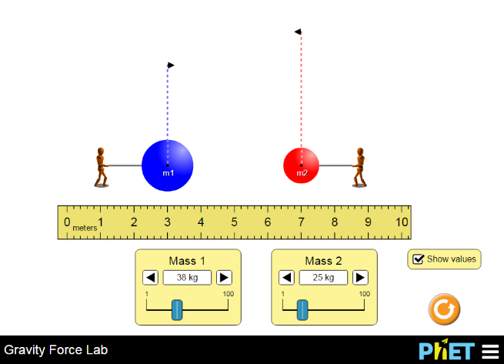
Determination of the Force of Gravity Simulation

Website: https://phet.colorado.edu/en/simulation/gravity-force-lab#for-teachers-header

Directions: Go to the website above and click on the play button within the photo on the page. Once there, click on “Show values” to enable the force calculations to be shown, and then start with the activity below! Have fun!

Qualitative Observations
- How does the changing the separation of the objects affect the force between them? (increases, decreases, not affected)

- What happens to the force between the objects when mass 1 increases? (increases, decreases, not affected)

- What happens to the force between the objects if Mass 2 decreases? (increases, decreases, not affected)

- What is the ratio of the force on the blue object to the force on the red object? What if the mass of the blue one is twice as big as the red object? Explain.

- What direction are the gravitational forces acting on the objects?

Quantitative Observations – learning by numbers

It is now time to build a model.

- What THREE things can we change/vary?

- Select an independent and dependent variable and constant

  - DV ___________________________

  - IV ___________________________

  - C ___________________________

- Collect 10 data points and graph

- Select a new independent and dependent variable and constant

  - DV ___________________________

  - IV ___________________________

  - C ___________________________

- Collect 10 data points and graph

- Repeat the varying mass vs. force experiment, changing the second mass.

Questions
- Explain why varying the second mass had the same effect on the force as varying the first mass.

- What is the relationship (aka proportionality) between mass and force? What happens to the force if you double the mass of the blue object? What happens to the force if you then triple the red object’s masses?

- What is the relationship between distance and the force of gravity? What happens if you triple the distance between the objects? Half the distance between them?

- Combine your relationships between Mass 1 (m₁), Mass 2 (m₂) distance (r) into a single equation that equals the Force of gravity (F_{g}).

