Practice problems for exam review: complete in notebooks.

1. In summer squash, white fruit color (W) is dominant over yellow fruit color (w) and disk-shaped fruit (D) is dominant over sphere-shaped fruit (d). If a squash plant true-breeding for white, disk-shaped fruit is crossed with a plant true-breeding for yellow, sphere-shaped fruit, what will be the phenotypic ratio of the F1 generation?

2. In the following autosomal dominant inheritance, complete the genotypes of each individual that can be said with certainty. If not certain, use the “dash” method we used yesterday to indicate “partially known”.
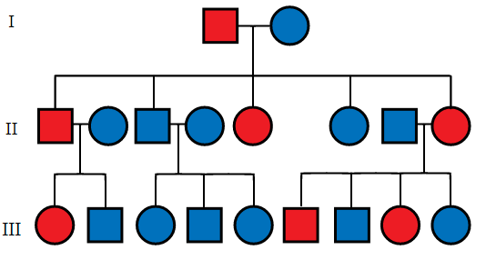
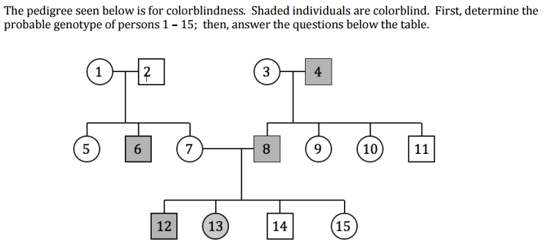

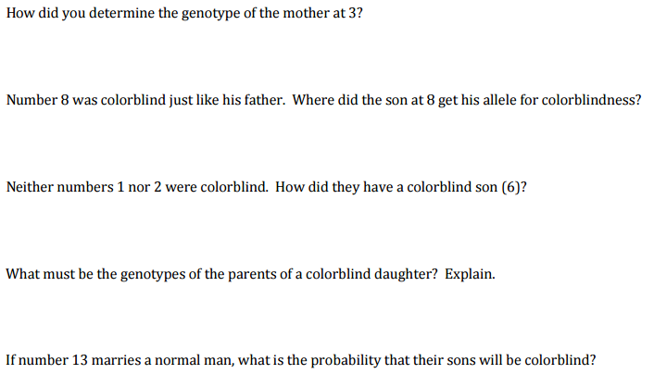

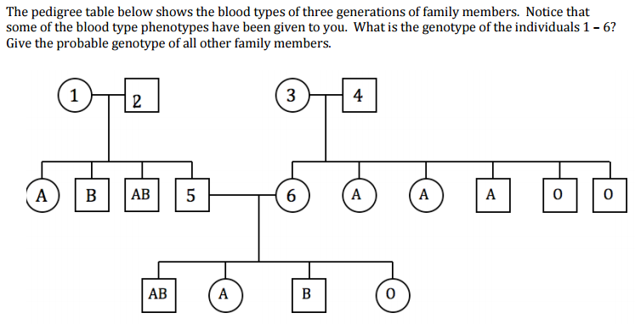

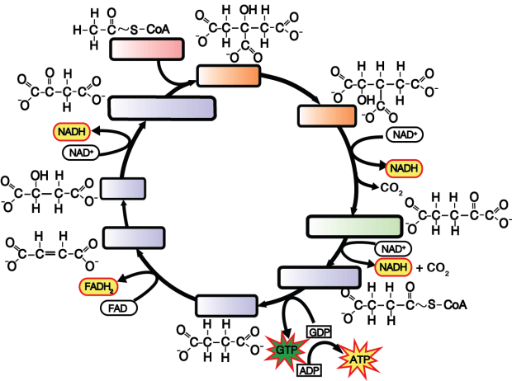

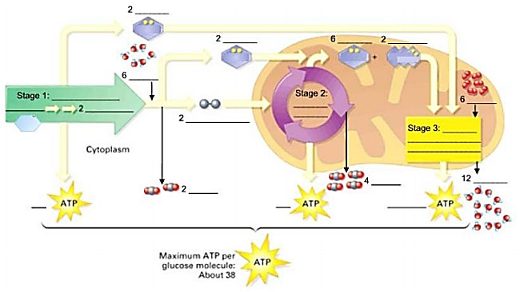

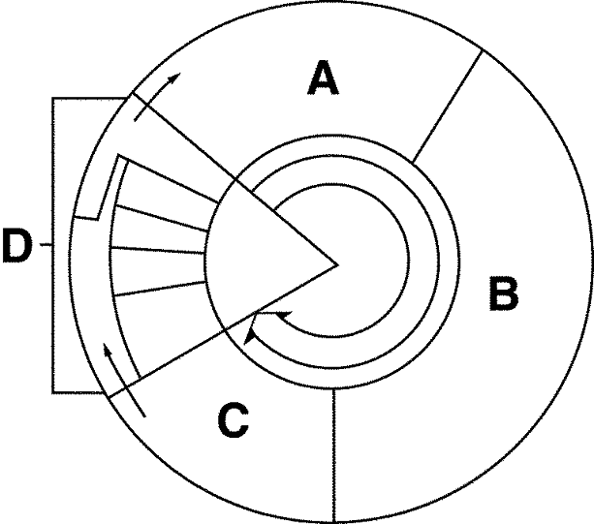

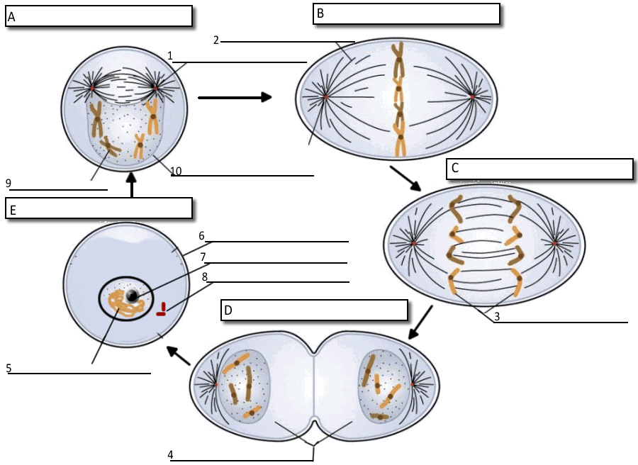

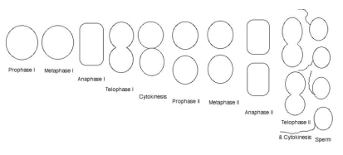
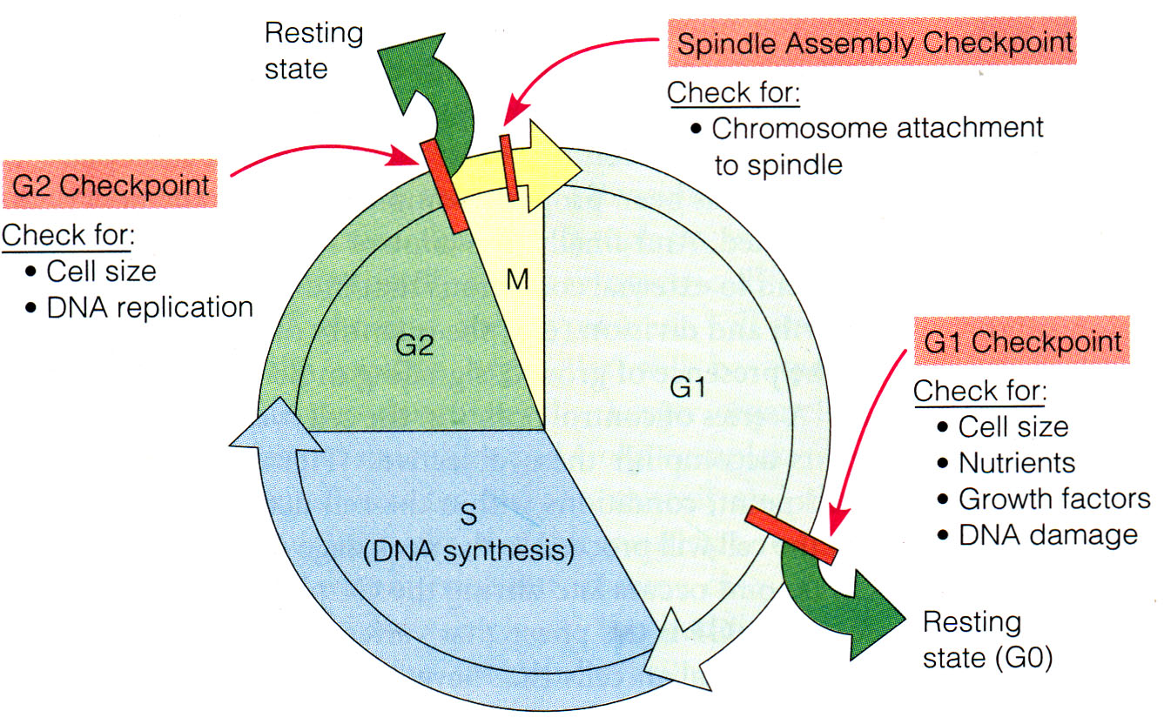
He re is a checkpoint diagram. Know this process and the cdk-cyclin complex function & levels.

Draw a two chromosome sperm mother cell’s gametogenesis

