Name _________________________
Inference or Observation? (I or O)
_____ 1. The volume of liquid is 30 mL
_____ 2. The color turns reddish-orange at 75 degrees
_____ 3. Condensation on a glass is from warm, moist air hitting a cold surface
_____ 4. The nest can hold three 25 gram eggs
_____ 5. The bowl-shape of a bird’s nest is what keeps the eggs from rolling out
_____ 6. The pond has grown more algae since our May visit

Independent or Dependent Variable? (IV or DV)
7. When different amounts of vinegar ( _____ ) is added to 20 grams of baking soda, produces different amounts of CO2 ( _____ ).
8. Wolf pack size on Isle Royal ( _____ ) is directly related to the moose population ( _____ ).
9. Temperature ( _____ ) will affect how well an enzyme functions ( _____ ).
10. H2O temperature ( _____ ) decreases with the more time it is left in a cool room ( _____ ).
11. The amount of oxygen produced ( _____ ) is directly related to leaf volume ( _____ ) in oak trees.

Data Presentation – Line graph (LG), Pie chart (PC), or Bar graph (BG)?
_____ 12. A comparison of the number of trees in 8 different tropical rainforests
_____ 13. Of all the insects in the world, the percent that is made up of Lepidoptera
_____ 14. The effect on plant growth as there is an increase in soil acidity
_____ 15. Contrasting a country’s gender and age profile for 2015
_____ 16. The change in atmospheric carbon dioxide over the last 100 years
_____ 17. T.A.I.L.S. refers most specifically to this type of graphical data representation

Statistics – match the description with its term.
_____ 17. Average/Mean a. The middle number in a series of data
_____ 18. Median b. Measure of how spread out the numbers in the data set are
_____ 19. Mode c. Sum of all the values divided by the number of values
_____ 20. Standard Deviation d. The most frequently observed value in a data set

What would the control variable be?
21. You test plant growth by giving plants different concentrations of acid solution.
CV: _________________________________________________
22. Experimenting how different colors of light effect plant growth.
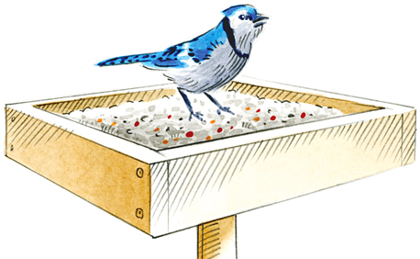
CV: _________________________________________________
23. Investigation of how different species of bird compete at a platform bird feeder.
CV: _____________________________________
24. You test how Mr. F’s tomato crop respond to different populations of caterpillars
CV: _____________________________________

Reflection Questions.
25. How does a scientific experiment differ from an investigation? Which do you think our bird nest engineering challenge was? Think variables, controls, observations, hypotheses, etc….

26. Why is the development of a study or experiment using the same set of steps an important thing to do in science?
27. Describe the steps of the scientific method and the importance of each.

28. Your friend does a scientific experiment and argues that he/she doesn’t need a control variable. Regardless of what he/she is experimenting, are they right? Explain why or why not? DETAILS…

29. If you were hired by the U.S. Department of Fish & Wildlife to work “The Effect of Red Fox Territory Size on Rabbit Population” project, propose what your I.V., D.V., and C.V. would be in this project. Write a hypothesis and scientific question. What would a control variable be for this project?

