FINAL EXAM STUDY PACKET

EXAM ONE

DO NOT WRITE ON THIS PART OF THE EXAM!!!!!
Exam One: Data & the Scientific Method (Version A)
Format: There will be 25 multiple choice questions worth 2 points per question. This is followed by 6 essay questions in which you will only CHOOSE TWO of to answer on the lined paper. Staple the lined paper to your bubble sheet when finished.

Directions: choose the correct answer for the questions based on the scenarios below and record it on your answer sheet.

Scenario 1.
If a person consumes more calcium in their diet their bones will become denser because there is a greater amount of the raw material present in the body to make bones with.
1. What is the independent variable (IV) for scenario 1?
a. amount of calcium consumed
b. bone density

2. Scenario 1 an example of a?
a. general hypothesis
b. directional hypothesis
c. measureable hypothesis
d. purpose

Scenario 2.
Perfumes with high amounts of ester compounds in them will increase the agitation levels of bumblebees.
3. Scenario 2 is an example of a
a. general hypothesis
b. directional hypothesis
c. measureable hypothesis
d. purpose

4. The dependent variable in scenario 2 is the
a. amount of ester compounds
b. the agitation level of the bumblebees
c. cannot determine from the information given

5. The purpose of a hypothesis in a scientific experiment is to
a. make a prediction about what the scientist believes the outcome will be
b. ask a question about what the scientist believes the outcome will be
c. provide information to design the experimental test around
d. both a & c
e. both b & c

Observations, Inferences, and Data.
6. The cheetah that is running at 55 m.p.h., weighs 95 pounds and has 2 cubs waiting in the grass.
a. observation
b. inference

7. There are 22 eastern coyote tracks per square foot in this location, the pack has to be at least 15 members large.
a. observation
b. inference

8. The large monk parakeet nest is located in the “Y” of a large limb of an oak tree, a nearly 50 foot tall hardwood tree.
a. observation
b. inference

9. The difference between qualitative and quantitative data is that
a. they both have to do with numerical values
b. they both have to do with the quality of something observed
c. quantitative has to do with characteristics
d. qualitative has to do with characteristics
e. both a & d

10. The difference between an inference and an observation is that
a. an inference is gotten using the five senses
b. an inference draws a conclusion from the data present
c. an observation is gotten using the five senses
d. an observation draws a conclusion from the data present
e. both b & c

11. You want to compare the number and types of species that live in a 10 square meter plot in the Amazonian rainforest, you would best represent the data using a
a. pie chart
b. bar graph
c. line graph

12. You want to show how fast ice from sea water melts compared to tap water ice as you increase temperature, you would best represent the data using a
a. pie chart
b. bar graph
c. line graph

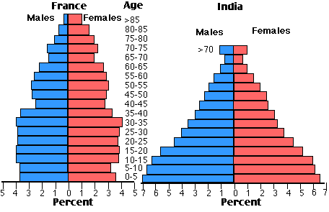

13. Using the population pyramids above, how would you compare France and India’s populations?
a. France has more people than India
b. India has less people from the ages of 0 to 15 years old
c. France’s population is stable while India’s is decreasing
d. India’s population is increasing while France’s is remaining stable
e. both a & d

14. The reason population pyramids are important to us is because they
a. help us to see gender differences
b. help us to see the age structure more clearly
c. help us to see whether populations are increasing, decreasing, or remaining stable
d. all of the above
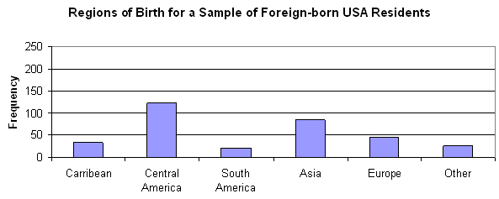

15. Look at the graph above and assess it for having all of the required characteristics correctly included. Which of the below is correct about it?
a. The x-axis label is missing
b. The interval of the graph is not correctly formatted
c. The scale of the graph is not correctly formatted
d. both a & c
e. none of the above

16. Should the data you get from your experiment not support your hypothesis, you can
a. you can’t do anything, once rejected, your experiment is finished
b. communicate your results because you finished
c. rewrite your hypothesis and redesign your experiment
d. retest using the same hypothesis
e. both c & d

17. Which of the following is most true about how we define a science?
a. Science is the steps involved with a process
b. Science is the knowledge gotten from study that helps us to explain the natural world
c. Science is the method used in an experiment
d. Science is a particular field of study
e. both b & d

18. The scientific method is vital to scientists because it
a. allows data to be compared even if the experiments are conducted in different locations
b. allows scientists the freedom to use any method(s) they feel will get supportive data
c. allows for a quick and easy answer to a scientific purpose
d. both a & c
e. none of the above
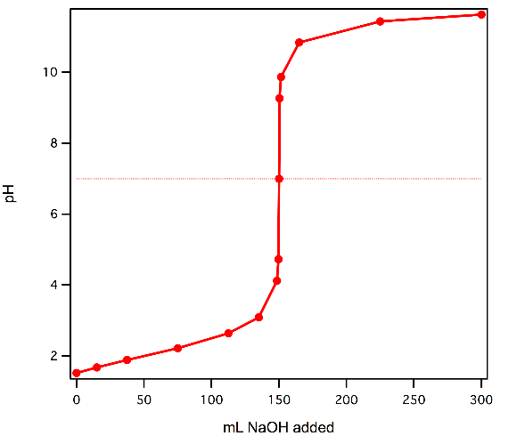
19. A correctly formatted title for the graph to the right would be
a. The effect of pH on the amount of NaOH added to a solution
b. The change in pH level of a solution
c. What is the effect of NaOH amount on the pH of a solution?
d. NaOH pH curve
e. none of the above

20. What important step of the scientific method contributes the most to the writing of an effective hypothesis?
a. Constructing a well-worded scientific purpose
b. Asking a perfectly formatted scientific question
c. Conducting extensive background research
d. Carrying out a perfectly planned scientific experiment to support the hypothesis
e. Miley Cyrus said so… (hint… don’t choose this one!) Relax, you’re almost done!

21. Many people put great degrees of faith in pseudoscience in many walks of life. Why would this be troubling to a dedicated scientist?
a. It would not be troubling, most scientists use pseudoscience in their fields of study
b. Because it does not provide data that is reliable and repeatable
c. It would be troubling because there is a series of steps always used to get accurate data
d. There are too many variables even though the data is accurate in the end
e. none of the above

22. Reasons for birds constructing cavity nests in hillsides can be because
a. certain birds can’t fly into dense tree cover to build nests
b. birds will use the materials and nest platforms that are available in the environment
c. it is an easy way to construct a nest
d. all birds are creative and adapt by making different nests in different locations
e. none of the above
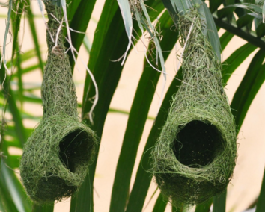

23. The nests in the photo above are called
a. cup nests
b. platform nests
c. cavity nests
d. pendulous nests
e. none of the above

24. The difference between a control variable and a constant is that
a. a control variables are changed over the course of the experiment, constants are not
b. a constant is an experimental condition that is kept the same in every trial of the experiment
c. a constant is what the measured data in the experiment is compared to see how much change there is
d. a control variable is the experimental variable without any treatment and is compared to the I.V.
e. both b & c

25. Dr. Bill has an experiment without a control variable. The biggest concern his assistant, Dr. Phil, has is that
a. they won’t be able to determine how significant the change they observe will be
b. they won’t have enough variables in the experimental design to make a large data set
c. they will have too many variable in the experimental design so removing it is okay
d. Dr. Phil should be fine with this decision
e. none of the above

END OF THE MULTIPLE CHOICE QUESTIONS!!!
OPEN-ENDED QUESTIONS. ANSWER ON LINED PAPER STAPLED TO YOUR ANSWER SHEET
Directions: NON-HONORS PEEPS answer any two of the three questions below, and HONORS PEEPS answer all of the questions below on the lined paper provided.

Scenario 1 - Bill’s Earthworms Scenario (10 points)
Biologist Bill is planning to conduct a long term study dealing with the preferred habitat of earthworms. Before beginning the experiment Bill writes the following investigative question. After reading the scientific question, write a hypothesis, identify the IV, identify the DV, and identify (3) three constants Bill should use on the lined paper provided.
Investigative Question: What habitat will an earthworm prefer?

Scenario 2 - Mr. F’s Tomatoes Scenario (10 points)
Mr. F is an avid tomato gardener but hasn’t seen the number of tomatoes on his plants as in years past. He wanted to test how the distance of honeybee nests to his tomato gardens affected the numbers of tomatoes grown. He used tomato beds with 6 tomato plants each, same species of tomato, planted at the same time, received the same water and sunlight, and were planted in the same mixture of soil. Mr. F built bee boxes (containers for bee hives) at 5 feet, 10 feet, 20 feet, and 50 feet from the tomato plants and enclosed each area with nylon mesh netting to keep the bees in. He also left one tomato bed in the open with no netting. He watered the plants every 2 days at the same time of day with the same amount of water for a period of 60 days.
Answer the following based on the scenario above:
- What is the control variable?
- What is the independent variable?
- What is the dependent variable?
- At least 3 constants
- Write a measureable hypothesis for this experiment

Scenario 3 - Peat Moss Scenario (10 points)
Norm wanted to know if adding peat moss to sand would affect its ability to hold water. He put 200 mL of pure sand into container A. He put a mixture of 80% sand and 20% peat moss into container B. He put a mixture of 60% sand and 40% peat moss into container C. He put a mixture of 40% sand and 60% peat moss into container D. He added water to each container and measured the amount of water the contents would absorb. He dried the sand and peat moss and repeated the experiment 5 times. He collected the following data.
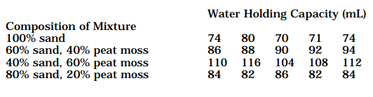

For the scenario above, answer the following questions:
- What is the I.V. and D.V.?
- What would an appropriate measureable hypothesis be?
- What is the C.V. in the experiment?
- What would your conclusion for this experiment be? DETAILS ARE KEY HERE.

EXAM TWO

Exam #2 Focal Topics

The chemistry of water
Structure
Polarity
Properties
Biological macromolecules (lipids, carbohydrates, nucleic acids, & proteins)
Carbon based molecules
Bohr models
Lewis dot structures
Using dot structures to draw structures
Valence electron usage
Ionic & covalent bonding
Cell structure – organelles (Cell city)
Prokaryote (bacteria) vs. Eukaryote cells
Membrane structure and function
Types of Membrane transport
Osmosis
Diffusion (or passive diffusion)
Facilitated diffusion
Active transport
Cell tonicity in varying concentrations of solutions
Isotonic
Hypotonic
Hypertonic

How to study:

- Formula for acing this exam… At least 1.5 hours of studying per hour of class time covering the material
12 hrs. class time X 1.5 = 18 hrs. studying
This means an average of 3 hours per night if you want to ace this exam.

- Review all work that has been returned and practice all problems

- Re-read all your cornell notes on the lessons

- Retry any simulations or watch any animations that we did along the way.

Own the material…be a rock star! Cuz u are!

DO NOT WRITE ON THIS PART OF THE EXAM!!!!!
Exam Two: A Polarizing, Carbon Compound, Cell Structuring & Transporting Exam (Version A)
Format: There will be 22 multiple choice questions worth 2 points per question. This is followed by 6 essay questions in which you will only CHOOSE TWO of to answer on the lined paper. Staple the lined paper to your bubble sheet when finished.

PART ONE: Multiple choice.
Directions: choose the MOST correct answer for the questions below and record it on your answer sheet.

1. The elements within a water molecule are held together by which type of bond?
a. ionic bond
b. hydrogen bond
c. covalent bond
d. double bond
e. none of the above

2. Cohesion occurs due to which type of bonding?
a. ionic bond
b. hydrogen bond
c. covalent bond
d. double bond
e. both a & b

3. Which of the following is not one of water’s special properties?
a. high specific heat
b. more dense as a solid
c. high heat of vaporization
d. high surface tension
e. none of the above

4. Which term or combination of terms best help to explain why a drop of water is less spread out on a waxy leaf’s surface than it is on a glass surface?
a. ionic & covalent bonding
b. adhesion & cohesion
c. capillary action
d. high specific heat & heat of vaporization
e. both b & c
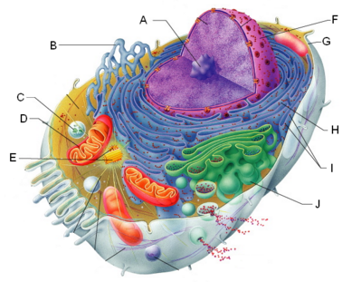
5. The diagram to the right is an example of a(n)
a. prokaryote cell
b. eukaryote cell
c. animal cell
d. plant cell
e. both b & c

6. In the diagram to the right, which letter below represents the membrane-bound structure within which genetic material is stored?
a. A
b. D
c. H
d. F
e. none of the above

7. In the diagram above and to the right, this structure(s) is responsible for creating proteins and transporting them to the Golgi apparatus for packaging
a. B
b. D
c. H
d. I
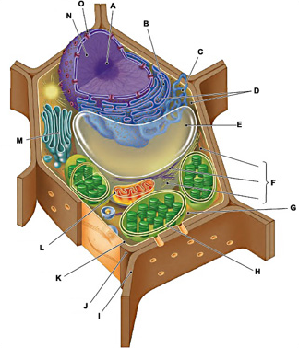
e. both c & d

8. In the diagram directly to the right, this structure is responsible for the production of ATP in this type of cell
a. A
b. D
c. L
d. M
e. none of the above

9. In the diagram directly to the right, this structure harnesses light energy and is what provides leaf color
a. A d. J
b. E e. H
c. L
10. In the diagram used in question 9, above, which structure is responsible for storing water and other solutes in this type of cell?
a. A
b. E
c. L
d. J
e. H

11. In a solution of 10% sugar and 90% water, you have placed a simulated cell that contains 30% sugar and 70 % water. Which of the following correctly describes OSMOSIS in this situation?
a. water moves into the cell
b. water moves out of the cell
c. water moves in and out equally
d. water does not move in the above situation.
e. none of the above

12. You decide to buy a new fish for your freshwater aquarium. When you introduce the fish into its new tank, the fish swells up and dies. You later learn that it was a fish from the ocean. Based on what you know of tonicity, the most likely explanation is that unfortunate fish went from a(n) _______________ solution into a(n) _______________ solution.
a. isotonic, hypotonic
b. hypertonic, isotonic
c. hypotonic, hypertonic
d. hypotonic, isotonic
e. none of the above

For # 13 – 15 below, match the direction of net movement on the right to the mode of transport on the left. The direction of net movement choices on the right may be used more than once.
____ 13. active transport a. solute movement from high to low concentration
____ 14. facilitated diffusion b. solute movement from low to high concentration
____ 15. simple passive diffusion

16. One major difference between bacteria and animal cells is that
a. bacteria have a nucleus surrounded by a nuclear membrane
b. bacteria cells have a capsule
c. animal cells have a capsule
d. animal cells have membrane bound organelle
e. both c & d

17. Cell membranes have a specific charge difference from one side of the bilayer to the other. Which of the below is true with respect to the structure of the phospholipid bilayer?
a. phospholipid heads are non-polar and the fatty acid tails are polar
b. phospholipid heads are polar and the fatty acid tails are non-polar
c. fatty acid tails are attracted to the aqueous environments inside and outside the cell
d. phospholipid heads are attracted to the aqueous environments inside and outside the cell
e. both b & d are correct

18. For active transport to occur, what important chemical energy molecule is required?
a. glucose
b. ATP
c. chloroplasts
d. mitochondria
e. both a & b

19. In discussing the chances of overdosing on vitamins, what about the structure of a cell membrane will make the overdose on vitamin C different than that of vitamins A, D, E, or K?
a. water soluble, or polar vitamins can easily pass through the membrane
b. lipid-based vitamins cannot pass through the membrane due to their polar charge
c. non-polar fatty acid tails within the cell membrane allow lipid-based vitamins to easily pass
d. polar phospholipid heads easily allow the water soluble, or polar vitamins to pass into the cell
e. none of the above

20. Which of the following is NOT a major function of membrane proteins?
a. cell surface identity marker
b. transporter
c. cell surface receptor
d. enzyme factory
e. site for enzyme activity
21. Of the four major carbon-based molecules of life, which of these makes up DNA and RNA?
a. protein
b. carbohydrate
c. nucleic acid
d. lipid

22. Of the four major carbon-based molecules of life, which of these is the glucose we store for energy?
a. protein
b. carbohydrate
c. nucleic acid
d. lipid

END OF MULTIPLE CHOICE ~ END OF MULTIPLE CHOICE ~ END OF MULTIPLE CHOICE!

PART TWO: ESSAY – to be completed on lined paper provided
Directions: write the answer to your open-ended questions on the lined paper provided.
E1. Mandatory. Draw the Bohr model of an atom of carbon showing: (a) the number of protons and neutrons in the nucleus, (b) the electrons correctly placed in their orbitals, and (c) explaining how many bonds this atom will form and why this is so (6 points).

E2. Mandatory. Show your work for drawing the Lewis structure of the greenhouse gas methane (CH4). Then do the same thing for a more harmful greenhouse gas, chlorofluorocarbon (CCl2F2) (6 points).

E3. Mandatory. Describe in detail what is meant by the “Fluid Mosaic Model”. Who came up with this important explanation and how did your bubble lab help you to understand this concept. DETAILS ARE REQUIRED HERE FOR FULL CREDIT (4 points).

How a Fairchild Wheeler biologist takes a selfie…
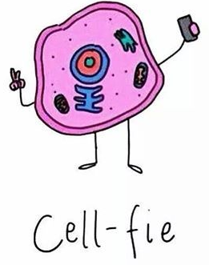

EXAM THREE

Exam Three Topics List
List of exam topics and avenues of study.
Exam date: Tuesday, 26 April 2016. There will be a review after school on Monday for anyone who would like to attend.

1. Microscope anatomy and proper use
- calculation of total magnification
- field of vision and light intensity changes with greater magnification
2. Proper wet mount technique
- why use a cover slip as it relates to the depth of field (remember the threads?)
- why contrast dyes are necessary
3. mitochondria structure (inner & outer membrane, matrix, cristae, inner membrane space)
4. chloroplast structure from simulation and photosynthesis reactions (light-dependent & light-independent, or light reaction & Calvin Cycle).
5. chemical reactions for cellular respiration and photosynthesis and how they’re related
6. know what is needed to start each “third” of the cellular respiration process as well as what is produced, or handed off to the next “third”, how many ATP are produced, if it is an aerobic/anaerobic step, and what any byproducts are (CO2, H2O). Be able to draw out the entire process.
7. what organisms does fermentation occur in? Why it occurs? Which of the steps of cellular respiration does it occur in?
8. what becomes the terminal electron acceptor in fermentation?
9. from the Everest video and related reflection, know how oxygen, glucose, and cellular respiration are closely connected in this dangerous environment.
10. the muscle fatigue lab (Mr. F’s revenge lab) concepts
11. the yeast lab and cellular respiration

Remember, there are a number of Cornell note sets you took as well that should be used to review for this exam that will also be material that you will be responsible for.

DO NOT WRITE ON THIS PART OF THE EXAM!!!!!
Exam Three: A Magnifying and Energetic Exam (Version A)
Format: There will be 25 multiple choice questions worth 2 points per question. This is followed by 1 essay question to answer on the lined paper. Staple the lined paper to your bubble sheet when finished.

PART ONE: Multiple choice.
Directions: choose the MOST correct answer for the questions below and record it on your answer sheet.

1. To properly carry Mr. F’s babies, the two microscope parts you should you be holding are the
a. ocular
b. neck
c. back
d. base
e. both b & d
2. For a microscope setting that has a 10x ocular and a total magnification of 400x, the objective lens in use is
a. low power
b. medium power
c. high power
d. oil immersion
e. none of the above

3. We name them “compound microscopes” because of
a. how they magnify objects
b. how the total magnification is from the multiplication of the low and high power objective lens power
c. how the total magnification is from the multiplication of the ocular and high power objective lens power
d. how the total magnification is from the multiplication of the ocular and objective lens power
e. none of the above

4. When you move from low power to high power total magnification, the amount of light you see transmitted through your specimen when you look through the ocular
a. decreases
b. increases
c. does not change
d. none of the above

5. To better illuminate your specimen as you change lenses, which of the below options is your best choice
a. the coarse focus
b. clean the lens with a lens cloth
c. iris diaphragm
d. illuminator adjustment
e. both c & d

6. On your microscope, the lens that will allow the most amount of light through to the eyepiece is the
a. low power
b. medium power
c. high power
d. oil immersion
e. ocular

7. Which of the following is NOT a correct item to check when putting away your microscope?
a. stage is set all the way up
b. the plastic cover is over the entire microscope
c. the cord is securely wound and stowed away
d. the high power objective lens is left in place
e. all of the above are correct items to check when putting away a microscope

8. As you transition from the high power to low power objective lens, the field of view
a. decreases
b. increases
c. stays the same
d. none of the above

9. The substance necessary to make sure we can see a specimen under a coverslip versus the lighted background is called a
a. contrast dye
b. iodine
c. Lugol’s solution
d. methylene blue
e. all of the above

10. A reason for using a coverslip over your specimen when using a microscope is to
a. minimize the depth of field to more easily locate your specimen
b. minimize the depth of field with no impact on locating your specimen
c. to protect your specimen while viewing
d. both a & c
e. none of the above

11. What phase of cellular respiration does the CO2 come from that you exhale with every breath?
a. glycolysis
b. Kreb’s cycle
c. electron transport chain
d. lactic acid fermentation
e. none of the above

12. This process does not occur in the mitochondria due to the large size of the molecules used
a. glycolysis
b. Kreb’s cycle
c. electron transport chain
d. lactic acid fermentation
e. none of the above

16. The correct reaction for cellular respiration is
a. C6H12O6 + O2 C02 + H20 + ATP
b. 6CO2 + 6H20 + LIGHT ENERGY C6H12O6 + 6O2
c. C6H12O6 + 6CO2 6O2 + 6 H20 + 36-38 ATP
d. C6H1206 + 602 6CO2 + 6 H20 + 36-38 ATP
e. None of the above

17. This theory explains why the mitochondria and chloroplast took residence and now have become a permanent part of animal and plant cells
a. the theory of evolution
b. the endosymbiotic theory
c. the organelle theory
d. the cell theory
e. both b & d are correct

18. The importance of the intermembrane space of the mitochondria for the electron transport chain is to
a. be an area of storage for electrons pumped through the protein complex
b. allow for the attraction between hydrogen ions
c. be an area of storage for hydrogen ions for later use with ATP Synthase
d. allow for the potential energy needed to recharge ADP ATP using ATP Synthase
e. both c & d

19. To be anaerobic respiration, this condition must be present
a. CO2 is not present in the cellular environment
b. too little glucose is present in the cellular environment
c. too little oxygen is present in the cellular environment
d. both b & c
e. none of the above

20. This is the terminal electron acceptor in cellular respiration that cleans up the electrons and hydrogen ions in the ETC?
a. ½ O2
b. ATP synthase
c. NADH
d. FADH2
e. none of the above

21. What is the molecule called that keeps the ETC replenished with hydrogen ions and electrons?
a. terminal electron acceptor
b. water
c. terminal electron carrier
d. electron carrier
END OF MULTIPLE CHOICE ~ END OF MULTIPLE CHOICE ~ END OF MULTIPLE CHOICE!

Essay:
On the lined paper given to you, you are to diagram or correctly describe BOTH of the following processes:
- Aerobic respiration
- Anaerobic respiration (2 types)

-Include the following:
-All major phases in it
-Is oxygen involved
-How many ATP are produced
-Where in the cell does it occur?

EXAM FOUR

Exam Four Topic List to Study – EXAM DATE FRIDAY, 13 MAY 2016

I. Bacteria
Material to use: Notes from class lecture
Bacterial grab bag assignment

Topics: Bacteria structure
What causes them to be pathogenic?
How do they differ from eukaryote cells? Organelles? Reproduction?

II. Mitosis & Meiosis
Material to use: Notes from class lecture
Mitosis & meiosis worksheets (dated 4/20 & 4/21, respectively)
Onion root tip lab (online – dated 4/19)
How chromosomes replicate and move during mitosis & meiosis
Mitosis in Ascaris & Onion Root vocabulary list (4/27)
Mitosis Cell Cycle Review/Practice (4/28)
Eukaryotic cell & cancer worksheets (Mr. F will hand back)

Topics: Cell cycle circular diagram
Major events in each phase
Identify a cell in each phase
Animal vs. Plant cell mitosis differences
Cellular hardware needed to make the chromosomes properly separate
III. Eukaryotic Cells & Cancer
Material to use: HHMI Biointeractive activity (“the eukaryotic cell cycle and cancer”)

Topics: Cell cycle checkpoints and their purposes
Proto-oncogene vs. oncogene function
Tumor suppressor gene function
Function of the G0 phase
What apoptosis is and why it’s important?
IV. DNA
Material to use: DNA model challenge packet
Notes from class lecture
PowerPoint on the discovery of DNA and the scientists involved
Computer based activities from 4 May

Topics: Structure
3 bonds present
Chargaff’s rules and data
Scientists’ work toward the discovery of DNA’s structure
Frederick Griffith
Avery, McCarty & McLeod
Alfred Hershey & Martha Chase
Erwin Chargaff
Maurice Wilkins & Rosalind Franklin
James Watson & Francis Crick

DO NOT WRITE ON THIS PART OF THE EXAM!!!!!
Exam Four: Cell Division, Bacteria, and DNA
Format: There will be 25 multiple choice questions worth 2 points per question. This is followed by 1 essay question to answer on the lined paper. Staple the lined paper to your bubble sheet when finished.

PART ONE: Multiple choice.
Directions: choose the MOST correct answer for the questions below and record it on your answer sheet.

1. The shape of DNA can best be described as a
a. twisted ladder
b. double helix
c. spiral
d. all of the above
e. none of the above

2. Deoxyribose is chemically bonded to the phosphate group in DNA by a
a. phosphodiester bond
b. hydrogen bond
c. glycosidic bond
d. none of the above

3. Adenine is attracted to thymine by what type of “bond”?
a. phosphodiester bond
b. hydrogen bond
c. glycosidic bond
d. none of the above

4. The backbone of the DNA molecule is composed of
a. alternating phosphate groups and nitrogenous bases
b. alternating nitrogenous bases
c. alternating deoxyribose molecules and phosphate groups
d. alternating deoxyribose molecules and nitrogenous bases
e. none of the above

5. Meselson and Stahl called DNA replication “semi-conservative” because
a. the replication happens very slowly
b. the replication happens only half way
c. both DNA copies have one parent strand and one brand new strand
d. one DNA copy had two parent strands and the other had two brand new strands
e. none of the above

6. Which of the following are true about Chargaff’s rule for DNA?
a. adenine only pairs with thymine, guanine only pairs with cytosine
b. adenine only pairs with guanine, thymine only pairs with cytosine
c. purine : pyrimidine ratio is always 1:1
d. both a & b
e. both a & c

7. How do we tell which side of a DNA strand is 5’ and which side is 3’?
a. by the direction the phosphate group is facing
b. by the direction the nitrogenous bases are facing
c. by the direction the deoxyribose molecules facing
d. by the way the carbon atoms within the deoxyribose are numbered
e. both c & d

8. The scientist(s) who discovered that DNA was helix shaped using x-ray crystallography were
a. Avery, McCarty, and McLeod
b. Hershey and Chase
c. Wilkins and Franklin
d. Watson and Crick
e. Griffith

9. The scientist(s) who determined that DNA was the genetic material that caused non-pathogenic rough Pneumococcus bacteria to become pathogenic when grown with heat killed smooth bacteria was
a. Avery, McCarty, and McLeod
b. Hershey and Chase
c. Wilkins and Franklin
d. Watson and Crick
e. Griffith
10. Griffith’s research on Pneumococcus bacteria and his accidental discovery of transformation contributed to the discovery of the structure of DNA by revealing that
a. a compound within the heat-killed smooth bacteria turned the rough strain into a pathogenic strain
b. DNA was the genetic material by isolating it from other carbon-based compounds
c. the structure of DNA was a double helix
d. adenine bonds only with cytosine and guanine bonds only with thymine
e. none of the above

11. In Hershey and Chase’s contribution to the discovery of DNA, the radioactive “marking” of the S35 and P32 helped to
a. determine if the bacteriophage protein coat carried the genetic material that it injected into E. coli
b. determine if the bacteriophage DNA carried the genetic material that it injected into E. coli
c. determine if the pellet in the centrifuge tubes was radioactive or not, identifying the genetic material
d. rule out any compound that was not found in the fluid above the pellet after centrifugation
e. all of the above

12. Eukaryote cells divide by mitosis but prokaryotes divide by
a. meiosis
b. binary fission
c. conjugation
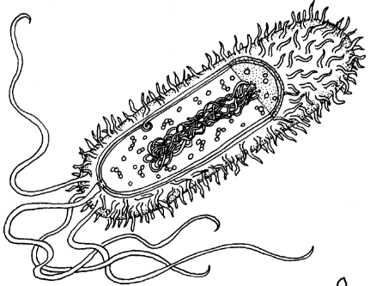
d. the cell cycle
e. none of the above

13. In the diagram to the right, the arrow is pointing at a
a. nucleus
b. ribosome
c. nucleoid
d. cytoplasm
e. pili

14. The type of archaebacterial that can live in extremely high heat and acidic environments is called a
a. prokaryote
b. halophile
c. methanogen
d. thermoacidophile
e. gram positive bacteria

15. The difference between the outcome of mitosis and meiosis is that
a. meiosis produces two exact copies of the same cell, almost clones
b. mitosis produces four different diploid sex cells, each entirely different
c. meiosis produces four different haploid sex cells, each entirely different
d. mitosis produces two exact copies of the same cell, almost clones
e. both c & d
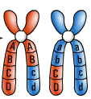
16. The phase of meiosis that you would see the structures in the picture to the right is
a. interphase
b. prophase I
c. metaphase I
d. prophase II
e. anaphase II

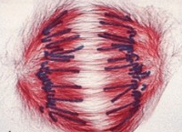
17. The phase of the cell cycle in the picture to the right is
a. interphase
b. prophase
c. anaphase
d. metaphase
e. telophase
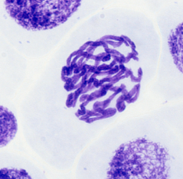
18. What major event is occurring in the cell in the picture to the right?
a. DNA has condensed into chromosomes
b. chromosomes are lining up along the metaphase plate
c. the nuclear membrane is starting to disintegrate
d. both a & c
e. none of the above
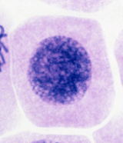
19. In the cell phase to the right, what major event(s) are happening?
a. DNA has not yet condensed into chromosomes
b. DNA replicates
c. cell grows
d. cell copies organelles and creates centrioles and spindle fibers
e. all of the above

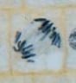
20. In the onion root tip cell to the right, the chromosomes are being pulled apart. What structure or cell hardware is attached to the chromosomes that are making them chromosomes move?
a. centrioles
b. spindle fibers
c. metaphase plate
d. centromeres
e. cell plate

21. A cell spends most of its life in
a. interphase
b. prophase
c. metaphase
d. anaphase
e. telophase

22. A reason(s) for a cell to enter the G0 sub-phase would be because
a. the cell was of average size
b. the cell will differentiate and divide in that phase
c. the cell copied its DNA and there is an error
d. the cell is small due to insufficient resources
e. none of the above

23. In the case that a cell is found to have severe damages or it is very old, the event to occur next is
a. mitosis
b. cell differentiation
c. apoptosis
d. all of the above
e. none of the above
24. P53 is a superhero protein in humans. It seeks out errors in DNA after it’s been replicated, but before it starts to form a cancer, and repairs the incorrect nitrogenous base sequence to save the cell. This cancer fighting protein is controlled by
a. proto-oncogenes
b. oncogenes
c. cell cycle regulators
d. tumor suppressor genes
e. cell cycle checkpoints

25. A difference between telophase in an animal and a plant cell is that
a. chromosome clusters for the new cells gather at the poles of an animal cell
b. muscle fibers pinch an animal cell to produce a cleavage furrow prior to cytokinesis
c. a nuclear membrane forms around the chromosome clusters at the poles
d. a cell plate forms between the chromosome clusters in a plant cell because there are no muscle fibers
e. both b & d

26. The difference between telophase I and telophase II in meiosis is that
a. there is half the number of chromosomes present in the “soon to be” cells in telophase II than in I.
b. there are the same number of chromosomes in each “soon to be” cell in both phases
c. telophase II is creating four diploid sex cells
d. telophase I is creating four haploid sex cells
e. none of the above

27. The subunits that make up all the nucleotides in DNA are
a. guanine, cytosine, and thymine
b. guanine, deoxyribose, phosphate group
c. sugar, deoxyribose, phosphate group
d. nitrogenous base, deoxyribose, phosphate group
e. hydrogen bond, sugar, phosphate
END OF MULTIPLE CHOICE ~ END OF MULTIPLE CHOICE ~ END OF MULTIPLE CHOICE!

Essay Question: write the essay question on the lined paper provided (6 points)
In the discovery of the 3-dimensional structure of DNA by James Watson and Francis Crick, describe IN DETAIL how the studies by Erwin Chargaff, and Maurice Wilkins and Rosalind Franklin contributed to the discovery. Specifically, a brief summary of the studies and how they helped Watson and Crick fill in the blanks to the structure.

