Na’am

Cells and Osmotic Potential
Directions: Define the following terms below. Type answers to this lab IN A DIFFERENT COLOR, and bold. Many answers can be gotten from the Introduction section below.
Selectively permeable membrane:
Diffusion:
Osmosis:
Equilibrium:

Cell Tonicity (defined as: a measure of the effective osmotic pressure gradient (as defined by the water potential of the two solutions) of two solutions separated by a semi-permeable membrane. In other words, tonicity is the relative concentration of solutions that determine the direction and extent of diffusion. It is commonly used when describing the response of cells immersed in an external solution.

Driving Question: Under what conditions do cells gain or lose water?

Introduction:
A cell membrane permits some materials to pass through while keeping other materials out. Such a
membrane is called a selectively permeable membrane (or semi-permeable). Under normal conditions, water constantly passes in and out of this membrane. This diffusion of water through a selectively permeable membrane is called osmosis. Like other substances, water diffuses from a region of higher concentration to a region of lower concentration. When the transfer of water molecules in and out of a cell reaches the same rate, a state of equilibrium is reached.

If the concentration of water molecules is greater outside a cell, then the solution is hypotonic to the
cell. Water will move into the cell by osmosis. The pressure against the inside of the cell membrane will steadily increase. If the pressure becomes great enough, the cell membrane will burst.

A solution is isotonic to the inside of the cell when there is the same concentration of water molecules on the inside and outside of the cell membrane. To maintain equilibrium, water molecules move into and out of the cell at the same rate.

Suppose a living cell is placed in a solution that has a higher salt concentration than the cell has. Such a solution is hypertonic to the cell, because there are more salt ions and fewer water molecules per unit volume outside the cell than inside. Water will move from the region of higher water concentration (inside the cell) to the region of lower water concentration (outside the cell). The selectively permeable membrane does not allow salt ions to pass into the cell. The cell shrinks as the cell loses water.

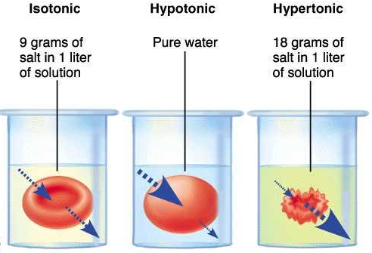
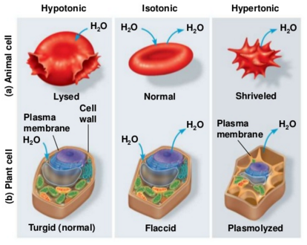
LAB: Go to http://www.glencoe.com/sites/common_assets/science/virtual_labs/LS03/LS03.html
In this Virtual Lab you will place a red blood cell, an Elodea cell, and a Paramecium in hypotonic,
isotonic, and hypertonic solutions. You will examine how and why these cells gain or lose water in the
different solutions.

Objectives:
·Describe the process of osmosis.
·Observe the movement of water through cell membranes during the process of osmosis.
·Compare and contrast three osmotic states: hypotonic, isotonic, and hypertonic.

Procedure:
1. Select one of the three cells pictured at the top of the screen and drag it into one of the beakers.
2. Observe the process of osmosis. Determine whether water, represented by animated blue arrows,
moves into, stays in equilibrium, or moves out of the cell. Observe what happens to the shape and size of the cell.
3. Record your observations in Data Table 1 below.
4. Move the cell to a different beaker or choose a different cell. Observe the process of osmosis again
and record your observations in the Data Table 1. Repeat this activity with all three cells and all three
solutions. Answer the Analysis Questions below and save the document to your “Completed Work” folder on your Google Drive. Type answers to this lab IN A DIFFERENT COLOR, and bold.
Data Table 1. Results of Cell Tonicity Study.
Molecule Name  Solution Type | Red Blood Cell  Net Water Movement (In/Out) | Red Blood Cell  Appearance of Cell (describe) | Elodea Cell  Net Water Movement (In/Out) | Elodea Cell  Appearance of Cell (describe) | Paramecium  Net Water Movement (In/Out) | Parmecium  Appearance of Cell (describe)
Hypotonic Solution

Isotonic Solution

Hypertonic Solution

Analysis Questions:
1. Did water move into the cell or out of the cell while it was surrounded by hypotonic solution?

2. In which direction did the water move through the cell membrane when the cell was surrounded by the hypertonic solution?

3. Compare and contrast what happens to an animal, a plant, and a Paramecium cell in a hypotonic, an isotonic, and a hypertonic solution.

4. Could Elodea or Paramecium from a freshwater lake be expected to survive if transplanted into the ocean? Explain.

5. If you were to grill a steak, would it be better to put salt on it before or after you cooked it? Explain why, in terms of osmosis.

6. Why does salad become soggy and wilted when the dressing has been on it for a while? Explain why, in terms of osmosis.

7. An effective way to kill weeds is to pour salt water on the ground around the plants. Explain why the weeds die, using the principles discovered in this Virtual Lab.

