Na’am ___________________________

How much can I get from a motion graph??

Directions: Answer the questions in the spaces provided below. REMEMBER to show all of your work to prove that you are the engineering rock stars that you are!!

WARMUP: Let’s start the engines. Provide the formulas for….
SPEED | TIME | DISTANCE | ACCELERATION | VELOCITY

PART ONE
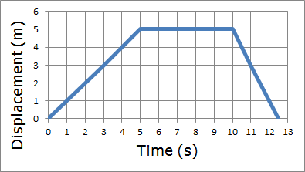
1. Describe the motion in the displacement vs. time graph to the left during the 5-10 second period? What characteristic of the graph made you give that answer?

2. There are two sloped lines in this graph, from 0-5 seconds, and again from 10-13 seconds. Knowing that this is a displacement vs. time graph, what do these two sections tell us about the kinematics (aka, the features or properties of an object in motion) of this object?

3. For the graph above, discuss where this individual/object started versus were they/it ended up.

4. What is the instantaneous velocity after 3 seconds?

5. What is the average velocity between 10-12 seconds? Think hard about this one.

6. What is the acceleration of the object between 0-4 seconds? Is this different from the acceleration between 10-13 seconds? EXPLAIN using words and numbers!

7. What vital piece of information does the slope of the line(s) in a displacement vs. time graph tell you?

PART TWO
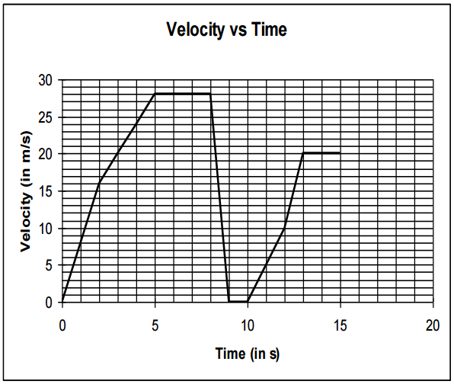
1. How fast is the car going at t = 3 seconds?

2. How fast is the car going at t = 9.5 seconds?

3. During what time period(s) is the car losing speed?

4. During what time period(s) is the car gaining speed at the highest rate? Explain what made you say this.

5. When is the car not moving?

6. During what time period(s) is the car moving at a constant speed?

7. The slope of a velocity vs. time graph tells you what vital piece of information about the moving object?

8. What is the acceleration of the object between 2-5 seconds?

9. What is the acceleration of the object between 8-9 seconds?

10. What is the acceleration of the object between 5-8 seconds? How does this acceleration differ from the acceleration between 13-15 seconds? Think about it, you’ve got this!

12. How far does the car travel from t = 5 seconds to t = 8 seconds?

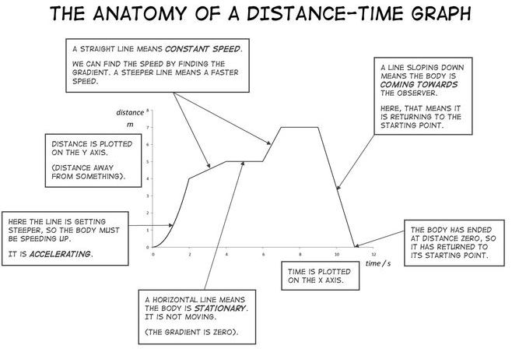
Some great tools to help you further understand motion graphs.

