Long Day & Short Day Plants and the Critical Night Length Practice Identification

1. ___________________________ is the environmental stimulus plants use to often detect the time of year.
2. __________________ plants do not depend upon the amount of darkness or daylight hours. These plants respond to the aging process. As the plant matures, the flower blooms or the plant flowers and sets fruit.
3. __________________ plants require less darkness to generate the reaction needed for production. These plants need about 8 hours of darkness to start flowering.
4. __________________ plants are those plants that flower when they are exposed to long periods of darkness and short periods of light. For a ___________________ plant to bloom, there must be less than 12 hours of daylight. These plants are controlled by maturity, not photoperiod.
5. Flowering and other responses to photoperiod are actually controlled by _________ length, not _________ length.
6. In general, ______________ (i.e. long-night) plants flower as days grow shorter (and nights grow longer) after 21 June in the northern hemisphere, which is during summer or fall.
7. _____________ plants flower when the critical night length falls below their critical photoperiod. These plants typically flower in the northern hemisphere during late spring or early summer as days are getting longer. In the northern hemisphere, the longest day of the year (summer solstice) is on or about 21 June.
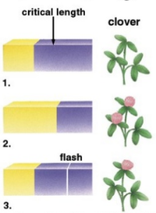
8. The diagram below to the left shows you that clover is which type of plant? ________________
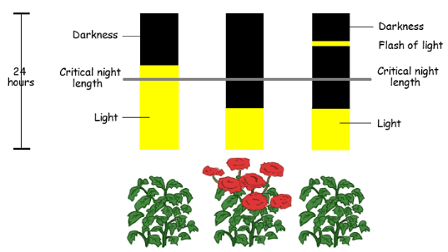

9. The diagram above to the right is a ___________________ plant.

10. On the lines below, indicate whether the plants in question are long day or short day.
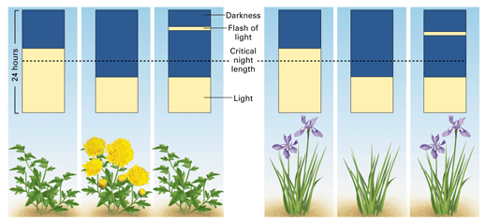
______________________ ______________________

11. On the lines below, indicate whether the plants in question are long day or short day.


  

  

