Name: ____________________________ Period: _________ Date: ________________
Challenge #4: The Lunar Lander Crash Landing

Overview:
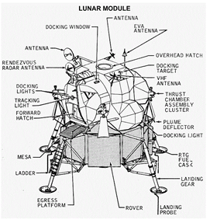
A lunar lander is a special type of space vehicle designed for landing on the surface at the Earth’s Moon. It’s objective is to get the humans on board landing safely onto the moon. The astronauts in the Lunar Module put the engine into full throttle to begin their descent to the moon. More than a dozen small thrust motors helped control the direction and speed of the descent to land the module gently. Because the moon has no atmosphere, crew members can’t calculate their altitude and airspeed. The Lunar Module sends out microwave beams to the moon's surface to provide information on the spacecraft's position.
At just a few thousand feet above the moon's surface, a computer onboard the spacecraft initiated the approach phase. The computer needed to adjust both horizontal and vertical speeds to almost zero, while the crew has to adjust for craters and other formations on the moon's surface to avoid a crash.
The Lunar Module commander had the choice of whether to land automatically using the craft's computers, or manually, depending on how clear the landing site was. The pilot learns how to steer the craft into a landing during simulations on Earth. When the Lunar Module landed, the commander hits the engine-stop button. The craft went into zero-gravity for a second and then the rocket engines on its bottom platform lowered it to the moon's surface.
In this project, we will be simulating a lunar landing during our egg drop. Yet, there are a few minor differences between a normal lunar landing and ours. In our case, our passengers (space crew) will be a normal sized, raw egg. And, our vehicle will be what you are creating. Instead of the lunar landing gliding nicely to the moon via the thrust motors, our “motors” have taken a turn for the worst. Somewhere in our flight our thrusters stopped working and our vehicles now have no choice but to be simply pushed by the force of gravity and freefalling to the concrete (the moon). We will drop our lunar landers from the 2nd story high plateau on the Terra Aerospace balcony onto the flat (the moon) below. Will your passengers stay alive? You will need to use your knowledge of impulse and engineer a change in momentum to minimize the force of the landing during this critical engine failure.

Objective:
Your objective is to design a Lunar Lander that saves your passenger’s (the egg) life when in a moon landing crisis. You will work in a group of 2. Your group will have roughly one period for the research and design (R&D - WEDNESDAY) process and a full period for the build (THURSDAY). You will then make a supremely professional Lunar Landing poster on Microsoft Publisher detailing critical aspects of how you engineered a lander to withstand such a crisis.

Rules:
- This lunar lander will be dropped from the high plateau, Terra Aerospace to Café Basin below.
- The lunar lander has to hit within the designated landing area on Café Basin.
- The lunar lander cannot use any sort of parachute or other mechanism to increase air resistance, because in space, would this even work??
- The lunar lander will be made out of the following materials ONLY:
- To obtain all materials, all groups will need to budget their $150,000 correctly for the materials they need.

1 Astronaut (egg…)  No cost (1 maximum) | 1 synthetic, space age cloth  $20,000 per piece (limit 2 cloths) | 1 Sponge  $20,000 ea (1 maximum) | 5 small solid support beams $10,000 f0r 5 – no limit
5 large hollow support tube $20,000 for 5 – no limit | (5) 8” x 11.5” flexible white “sheet metal” $35,000 for 5 sheets – no limit | 3 NASA impact bags $25,000 for 3 (one purchase limit) | 5’ flexible adhesive (in 1 foot pcs) $5,000 (limit 2 purchases)
1 NASA approved space adhesive stick & hot application gun use $5,000 (n0 limit) |  | - 12” x 12” sheet of space foam  $15,000 ea (3 maximum)

Prizes:
- 5 Extra credit points will be given to the group/groups of engineers that design a lander that can save the life of the astronaut passenger. This astronaut must be COMPLETELY INTACT. The distinction is made between completely intact, intact with cracks (not saved), or broken (definitely not saved, aka scrambled egg).

Products:
Your group will create the following products for the Egg Drop Extravaganza: (see RUBRIC for complete info)
- A Lunar Lander Sketch
- A Lunar Lander Crash-safe Prototype
- A Lunar Lander Crash Safety Poster
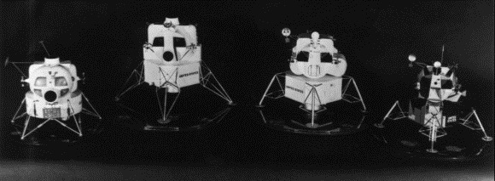
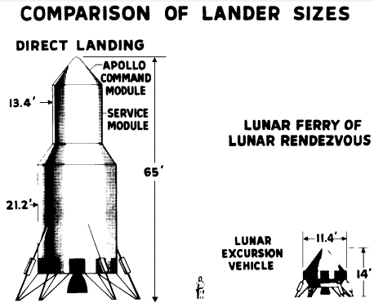
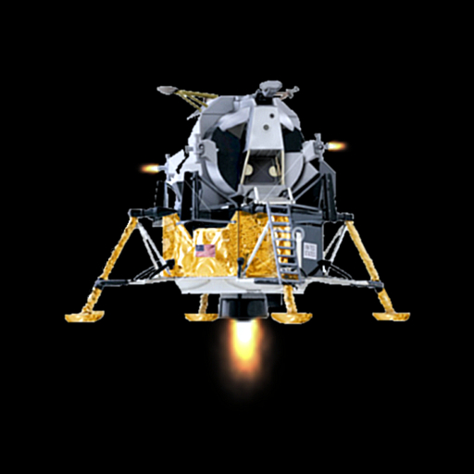
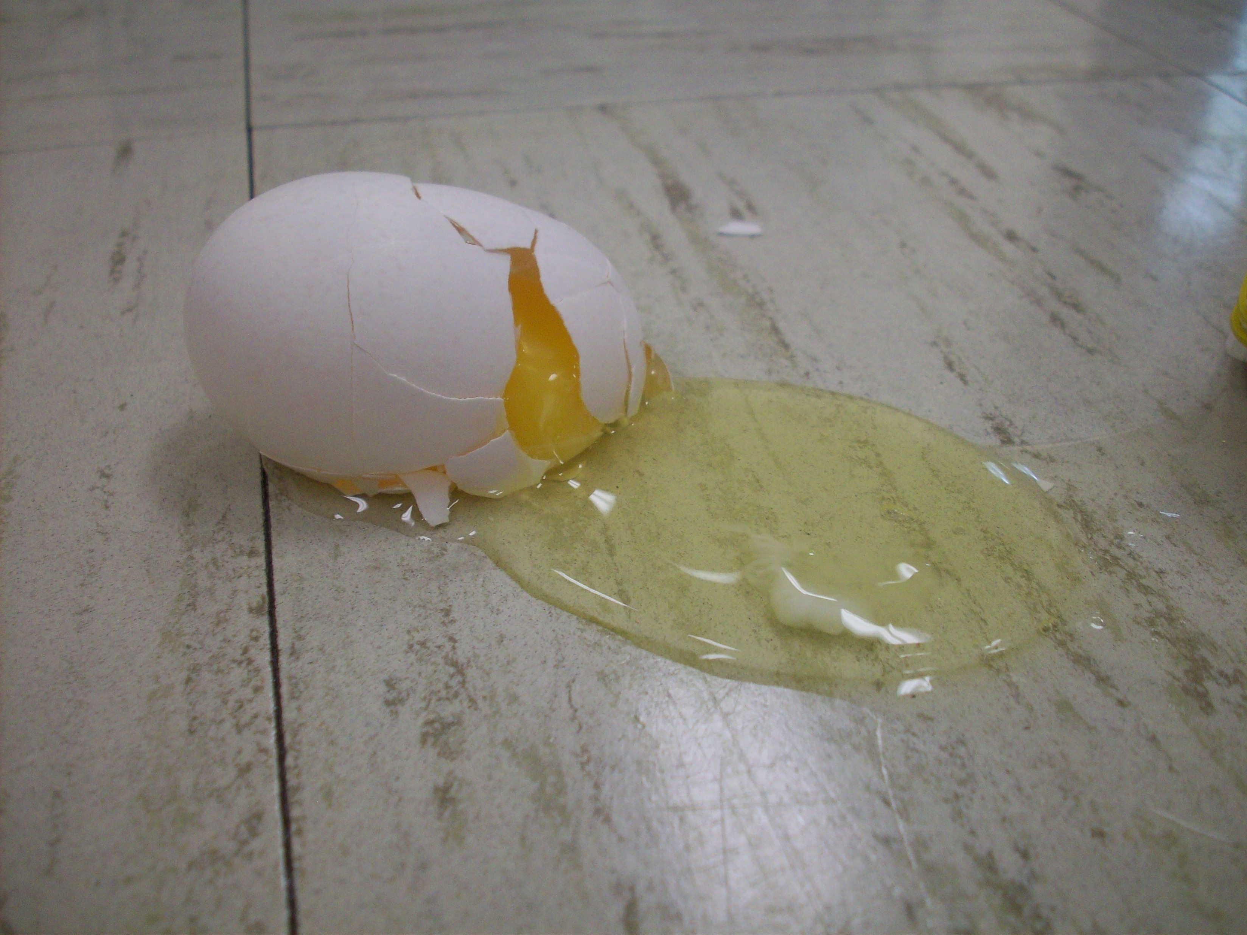

THE LUNAR LANDER CHALLENGE: GRADING CRITERIA & RUBRIC
Description | Points Earned | Points Possible
Lunar Lander Vehicle (LLV) Performance (40 points total)
LLV is designed and fully built by Friday test day |  | 20
Astronaut is: Completely Intact (20), fractures only (10), or is scrambled eggs (0)) |  | 20
Balance sheet is filled in completely and budget questions answered |  | 5
Sketches (10 points total)
Sketch of LLV with all components/parts labeled and dimensions in cm |  | 10
Sketch of engineering process and what you specifically did in this challenge in using the design/engineering process |  | 10
Subtotal 1 |  | 65

Description | Points Earned | Points Possible
Lunar Lander Safety Poster (50 points total)
Poster has a relevant title for the mission |  | 5
Poster has relevant pictures from the emergency landing |  | 5
Poster has design sketch with materials labeled |  | 10
Poster describes the DESIGN of lunar landers and why safety features are important! |  | 10
Poster fully answers MINIMUM 4 questions listed below (5 points each) |  | 20
Poster is professional |  | 10
Subtotal 2 |  | 60
FINAL PROJECT GRADE |  | 125

- Describe your Lunar Lander Vehicle. What methods did you take to insure our astronaut is protected in the event of a crash landing?
- Explain how the concepts of momentum and impulse relate to an emergency crash landing. Solve for velocity and momentum from your recorded data.
- Describe how the Impulse-Momentum Theorem has helped your astronaut to survive through your problem solving and engineering skills. Use the equation to help you do this.
- In order for your astronaut to survive, explain what the collision with the ground should be like with respect to contact time and how you maximized impulse to do this? USE DETAIL.
- Reflect on your design as an engineer would. How could you improve the design? (Explain this in terms of how you would increase impulse/reduce momentum) What materials would you have changed if given another trial?
- How can you use what you learned from this activity in real-world situations? Include an example!
- Describe the type of collision your LLV was involved in during this challenge. Provide details as to what a collision is, the type of this collision, and how the momentum and energy was conserved during the collision.

STUDENT ENGINEERS’ LUNAR LANDER
BUDGET BALANCE SHEET

Qty | Date | Description | Debit | Credit | Balance

Budget Questions:

1. How much of your budget did you spend on this build?

2. What was your biggest challenge in the budget department? How did you overcome this/any budget challenges?

3. What is the importance of balancing your materials budget? Do you think the budget can be thought of separately from the engineering/design of your LLV? EXPLAIN.

