Plasma Membranes
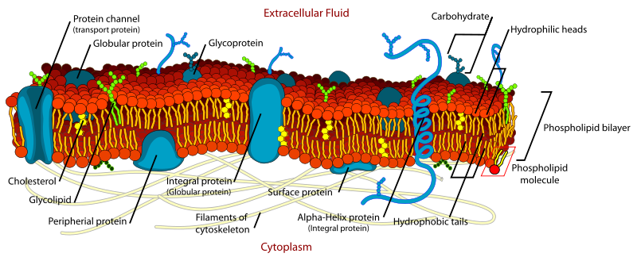

Lipids
- Easily dissolved in organic (C & H based – hydrophobic) solvents but not in water (hydrophilic)
- Triglycerides (fats and oils)
  - Consists of 3 fatty acids linked by ester bonds to a glycerol molecule
  - Excess energy available from food is stored as triglycerides (stored fat in animals)
  - Can be broken down to yield energy when needed
  - Contain twice as many energy stored per unit of weight as carbohydrates
- Saturated fatty acids
  - -COOH group without double bonds in the carbohydrate chain
  - May cause blockage of arteries which can lead to strokes and heart attacks
  - High melting point / solid at room temperature (fats) / typical animal fats
- Unsaturated fatty acids
  - -COOH group with double bonds in the carbohydrate chain
  - Low melting point / liquid at room temperature (oils)
  - Found in plants
- Phospholipids
  - Found in cell membrane
  - Formed by replacing one fatty acids in a triglyceride with a phosphate group
  - Phosphate is polar / hydrophilic / does mix with H2O
  - Fatty acid tails remain non-polar / hydrophobic / insoluble, does not mix with H2O

Fluid-Mosaic Model
- Membranes consist of a phospholipid bilayer dotted with proteins, polysaccharides, lipids (mosaic look)
- The lipid bilayer is semipermeable - H2O and some small, uncharged, molecules (O2, CO2) can pass through
- Phospholipids have two parts
  - "Head": hydrophilic → attracts and mixes with H2O
  - Two "fatty acid tails": hydrophobic

Diffusion
- Uses energy from moving particles (kinetic energy)
- Substances move down their concentration gradient until the concentration are in equilibrium
- Fick's Law → rate of diffusion across exchange surfaces (e.g. membrane, epithelium) depends on
  - Surface area over which diffusion occurs (larger area = more diffusion)
  - Thickness of surface (thinner membrane = more diffusion)
  - Difference in concentration gradient (larger difference = more diffusion)
- Microvilli
  - Extensions of the plasma membrane in the small intestine to help absorb nutrients easily
  - They increase the surface area of the membrane in the small intestine
  - Accelerate the rate of diffusion due to Fick’s Law
- Temperature increases rate of diffusion due to increasing K.E. (kinetic energy) of molecules
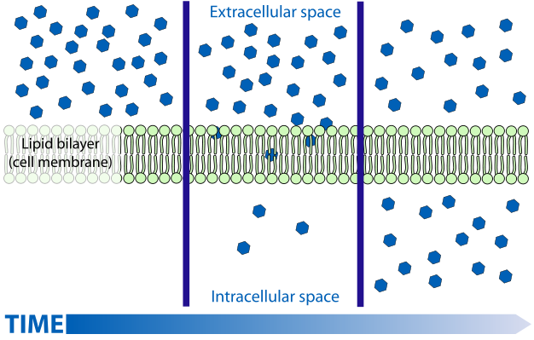

Facilitated Diffusion
- Transmembrane proteins form a water-filled channel
  - Allows the passage of ions (Ca2+, Na+, Cl-) down their concentration gradient
  - This is a passive process → no ATP required
  - Some channels use a gate to regulate the flow of ions
  - Selective permeability → not all molecules can pass through selective channels
- Transport mechanism
  - Carrier protein binds to substrate (specific molecule to be transported)
  - Carrier protein’s molecular structure changes shape after substrate binds to it
  - Release of the diffusing molecule (substrate) on the other side of the membrane
- Example
  - If you want to move a muscle, a nerve impulse is sent to this muscle
  - The nerve impulse triggers the release of a neurotransmitter
  - Neurotransmitter binds to a specific transmembrane protein
  - The protein opens channels that allow the passage of Na+ across the membrane
  - In this specific case, this causes muscle contraction
  - These Na+ channels can also be opened by a change in voltage
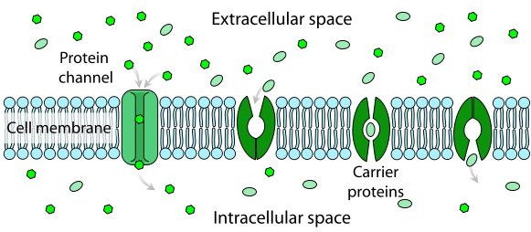

Osmosis
- Special term used for the diffusion of water through a permeable cell membrane more permeable to one substance than another
- Transmembrane proteins that form hydrophilic channels accelerate osmosis, but water is still able to get through membrane without them
- Water is polar and able to pass through the lipid bilayer with help from many water channels AND looser part of membranes made up of phospholipids with a large number of unsaturated fatty acid tails. This makes them space further apart, thus allowing water to pass when it wouldn’t with saturated tails present

- Osmosis generates pressure called osmotic pressure
  - Water moves down its conc. gradient
  - When pressure is equal on both sites net flow ceases (equilibrium)
  - The pressure is said to be hydrostatic (water-stopping)
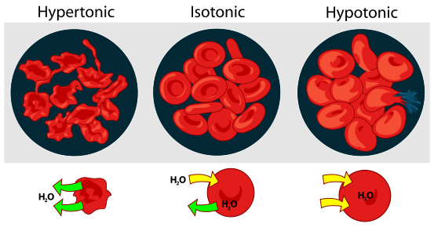

Water Potential
- Measurement of ability or tendency of water molecules to move
- Hypotonic: solution with a lower conc. of solute / gains water by osmosis
  - Solution is more dilute
  - Cells placed in a solution which is hypotonic will grow as water moves in
  - Red blood cells will swell and burst if it is in a hypotonic solution
  - Plant cells are unable to burst due to their strong cellulose wall
- Hypertonic: solution with a higher conc. of solutes / loses water by osmosis
  - Cells will shrink in hypertonic solutions (example: red blood cells)
- Isotonic: solutions being compared have equal conc. of solutes
  - Cells which are in an isotonic solution will not change their shape
  - The extracellular fluid of the body is an isotonic solution
- Molecules collide with membrane / creates pressure = water potential
- More free water molecules, greater water potential, less negative
- Solute molecules attract water molecules which form a "shell" around them
  - water molecules can no longer move freely
  - less "free water" which lowers water potential, more negative

Active Transport
- Movement of solute against the concentration gradient, from low to high concentration
- Involves materials which will not move directly through the bilayer
- Molecules bind to specific carrier proteins / intrinsic proteins
- Involves ATP by cells (mitochondria) / respiration
  - Direct active transport - transporters use hydrolysis to drive active transport
  - Indirect active transport - transporters use energy already stored in gradient of a directly-pumped ion
- Bilayer protein transports a solute molecule by undergoing a change in shape (induced fit)
- Occurs in ion uptake by a plant root; glucose uptake by intestinal cells
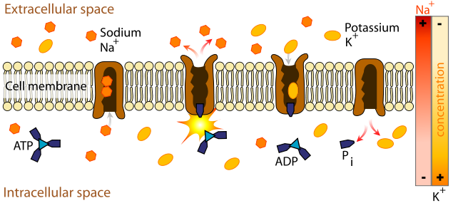

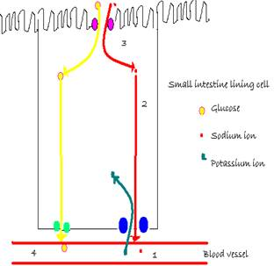
The Absorption of Glucose from the Small Intestine
The chemical digestion of carbohydrates results in the production of monosaccharides such as glucose. These need to be absorbed by the small intestine and passed into the bloodstream for use by the body. The process of diffusion alone would not result in all of the glucose present in the small intestine being absorbed as an equilibrium would be reached and any remaining glucose would pass out of the body in the feces. Our digestive systems have evolved to absorb all of the glucose produced.
Glucose is therefore absorbed by the small intestine using an active process. It is considered an active process because ATP is required for it to happen. However it uses the ATP indirectly as it is the movement of sodium ions which actually powers the movement of glucose into the cells. It is also an example of CO-TRANSPORT because two molecules (glucose AND sodium) are involved.
- Sodium ions are actively transported out of the epithelial cell into the blood by the sodium potassium ATPase. This protein pump is present in the membrane of all eukaryotic cells.
- Sodium ions are now at a lower concentration in the epithelial cell than in the lumen of the small intestine.
- Sodium ions now diffuse down their concentration gradient through a co-transport protein present in the plasma membrane of the epithelial cell. The energy released as the sodium ions move down their concentration gradient allows glucose molecules to pass through the co-transporter too despite the epithelial cell having a higher concentration of glucose than the lumen of the small intestine.
- The glucose now passes into the blood via facilitated diffusion.
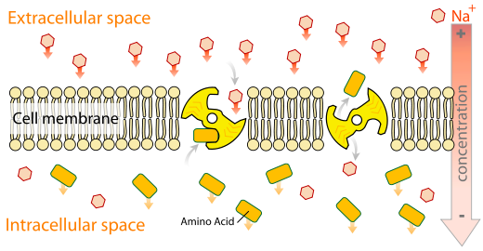

Cholera

Prokaryotic Organisms - Bacteria
- Bacteria are prokaryotes
  - Nucleus (5µm)
    - Contains chromosomes (genes made of DNA which control cell activities)
    - Separated from the cytoplasm by a nuclear envelope
    - The envelope is made of a double membrane containing small holes
    - These small holes are called nuclear pores (100nm)
    - Nuclear pores allow the transport of proteins into the nucleus
  - Undergo asexually reproduction by binary fission / 2 identical daughter cells
- Classification
  - Most bacteria require oxygen to survive: aerobic bacteria
  - Bacteria that are growing in the absence of oxygen: anaerobic bacteria
- Grow best at optimum conditions (human body)
  - Constant temperature
  - Neutral pH
  - Constant supply of food, H2O, O2
  - Mechanism removing waste
- Only a small number are pathogens. Pathogens cause disease by:
  - Damaging our cells; or
  - Producing toxins; or
  - Directing our immune system against our own cells
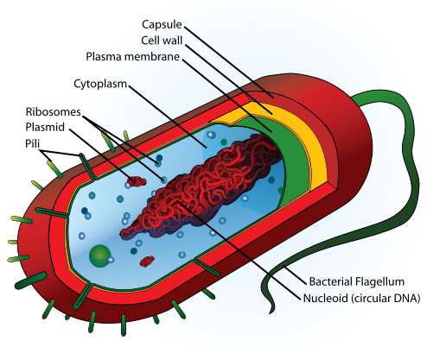

Vibrio Cholera
- Produces enterotoxins released from bacteria
  - Enters enterocytes (cells lining the surface of the intestine) by endocytosis
  - Activates the CFTR protein (cystic fibrosis transmembrane regulator) that controls water movement from the body into the intestines
  - Causes secretion of sodium, chloride and bicarbonate ions from enterocytes
  - Water follows sodium into the intestinal lumen
- Osmotic loss of up to 10L of water per day for infected individuals!
  - Results in severe watery diarrhea of sudden onset
  - Dehydration leads to death within hours if untreated
- Giving oral sodium would cause more water to be secreted into the intestine, worse!
- Giving oral glucose and sodium (oral rehydration therapy)
  - Glucose is still absorbed through the intestinal wall
  - This is done by a glucose-sodium co-transporter
  - Carries one glucose molecule and one sodium ion across the intestine into the blood
  - Water always follows sodium
  - Diarrhea is less severe and body becomes rehydrated
- Oral rehydration therapy (ORT) also contains potassium and bicarbonate ions
  - Prevents electrolyte imbalance
  - Prevents metabolic acidosis

