Monohybrid & Dihybrid Minions
Define the following terms:
Genotype
Phenotype
Homozygous
Heterozygous
Dominant
Recesive

1. In minions, sleek hair (S) is dominant to smooth hair (s). If a female minion who was heterozygous married a minion with smooth hair, what would the potential genotypic and phenotypic ratios of their offspring be? Use the space below to draw a Punnett square and correctly write out the two ratios.
Genotypic Ratio –
Phenotypic Ratio -

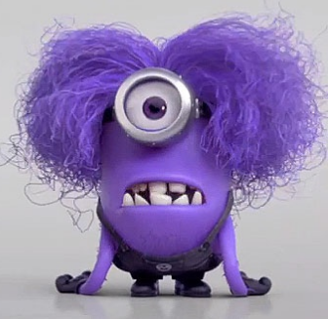
2. Hair thickness is controlled by the “T” gene in minions. Answer the questions below based on this.
a. If thick hair is dominant to thin hair, the genotypes for hair thickness is:
homozygous dominant (thick hair) - ___________
heterozygous (thick hair) - __________
homozygous recessive (thin hair) - ___________
b. Explain how each of the three genotypes in part “a” come to be by using the concept of dominance to describe it.

c. Should a homozygous dominant and homozygous recessive minion have offspring, what is the probability of having a thin haired offspring? Draw a Punnett square to help you explain. Do the same with the F1 generation.

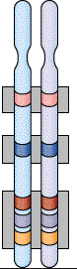
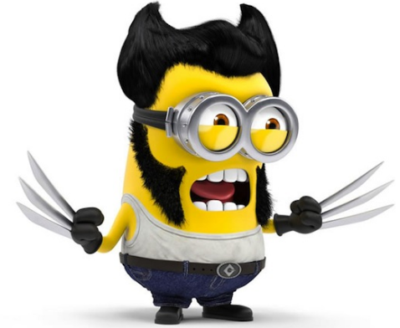
3. In Wolver-minion, the ability to tolerate adamantium (a metal) and the ability to form hand-knives are located on two different, and linked genes found on chromosome #9. The ability to tolerate adamantium is a recessive characteristic, as is the ability to form hand-knives.
a. Draw Wolver-minion’s genotype on the homologous chromosomes located to the left. Choose which genes the linked traits are found on and write his genotype on the picture.
b. There are two wolver-minions that meet and have an offspring. If Logan is homozygous recessive for both adamantium tolerance and ability to form hand-knives; and he has an offspring with Talus, a heterozygote for both traits, what will be the probability that their offspring will be able to tolerate adamantium and form hand-knives? Draw a Punnett square to help you.

c. Write the genotypic and phenotypic ratios for Logan and Talus’ potential offspring.
Genotypic ratio –
Phenotypic ratio -

