Motion Graph Analysis Worksheet

Analysis Questions: Answer the following questions in your notebook.

- Identify the type of motion that is occurring for each section of the graph (ie. constant velocity, positive acceleration, negative acceleration (aka deceleration), no motion, etc.)

- Between which two letters is the rate of speed the fastest? Why?

- The least amount of distance covered occurs between which two letters?

- Identify the type of motion occurring between letters C and D? Give evidence to support your reasoning.

- During the total journey, how many total seconds pass when the object not in motion?

- Calculate the average speed between letters B and C.

- How much distance did the object cover over the entire journey?

- Calculate the average speed for the entire journey from point A to point F.

- Write a short story (3-5 sentences) that describes a situation with the motion experienced in the graph.

C.
B.
A.
Distance
Time
Distance
Time
Distance

Time

F.
E.
D.
Distance
Distance

Distance

Time
Time
Time

Descriptions of Motion – write the correct description on the first line of each question below as they relate to the graphs above. Based on what you observe, describe why you have given it that description.
- Acceleration
- Constant Speed (high rate of speed)
- Constant Speed (low rate of speed)
- Negative Acceleration (deceleration)
- No Motion (stopped)
- Moving Backwards (constant velocity in reverse)

Graph A matches description ______ because _____________________________________________________________________.
Graph B matches description ______ because _____________________________________________________________________.
Graph C matches description ______ because _____________________________________________________________________.
Graph D matches description ______ because _____________________________________________________________________.
Graph E matches description ______ because _____________________________________________________________________.
Graph F matches description ______ because _____________________________________________________________________.
Motion Graphs - Part 2
B.
Speed
Time
Time
Speed
A.

Time
Speed
D.
C.
Speed
Time

Descriptions of Motion

- No Motion (stopped)
- Constant Speed
- Acceleration
- Negative Acceleration (deceleration)

Graph A matches description ______________________
Graph B matches description ______________________
Graph C matches description ______________________
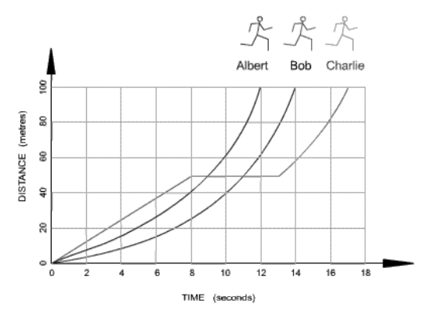
Graph D matches description _____________________
Use the graph to the right to answer the questions below.

Which runner won the race?
Which runner stopped for a break?
How long was the stop?

Calculate each racer’s average speed over the race.
Albert -
Bob -
Charlie -

