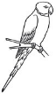
Objectives: Students will gain understanding of the purpose of a bird’s nest & learn about the five main types of nests.
Mr. F’s Bird Nest Engineering Challenge

Students will compare and contrast different bird species and the different types of nests they build.

Students will analyze the effect of habitat on nest placement.

Students will compare and contrast the different bird species and the use different materials to build their nests.

Students will analyze how nest size can help determine bird size.

Skills under fire in this challenge: Correct formatting of scientific questions, purposes, and hypotheses in pursuit of a solidly constructed, and functional, nest. Research and documentation. You will also be responsible for creating a materials list and set of detailed procedures, followed by a write up of your results. To effectively do this, you will need to work in a group setting and share your part of the workload. This is an integral part of project based learning.
Product(s): (1) A detailed research log complete with proper citations (one per group), (2) a functional nest replica that can support three large marbles (one per group), (3) a species identification card (one per group), and (4) a research report (one per student).
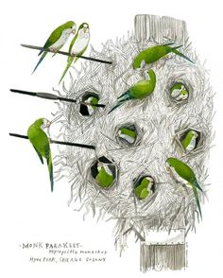
Introduction: Birds (Class Aves) reproduce by laying eggs, a calcium carbonate (CaCO₃) shelled structure in which a bird embryo develops. Eggs require a specific structure to hold them as the female, or male, incubates them for the between 11 and 50 days depending upon the species. Nests are marvels of engineering in the animal kingdom and even more fascinating when the species building them is considered a social species, like the sociable weaver (Philetairus socius) in Africa and the Monk parakeet (Myiopsitta monachus) in CT (!) and Amazonian highlands. These aren’t the only birds that form nests, however. It will be your task to research a bird species thoroughly and ask the appropriate question(s) in your effort to engineer a nest, just like a bird!
Project schedule: This will take place over a 5 day period over which you will also receive flipped lessons on procedure and conclusion writing. The schedule will go as follows:
DAY ONE: (1) Formation of groups, (2) Introduction & constraints, (3) expectations & products, and (4) begin group research log questions.
HW – procedure & conclusion writing (part one)
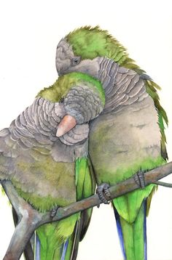
DAY TWO: (1) Research continued/completed, (2) Question/purpose & Hypothesis(es) are written out, (3) group approval for phase two, and (4) organize which student will be responsible for specific materials.
HW – procedure & conclusion writing (part two)
DAY THREE: (1) Build begins
DAY FOUR: (1) Build completed & tested, (2) Species identification cards completed, and (3) Start analysis questions.
HW – write a detailed set of steps that your group took to build your nest.
DAY FIVE: (1) Analysis questions complete, (2) Research report started. HW – complete research report and save to “Completed work” folder on or by 11:59 p.m. on:

Type day and date here:

Some Helpful research sites…
Cornell Lab of Ornithology: https://www.allaboutbirds.org/
BBC article on 16 Amazing Nests Built by Birds: http://www.bbc.com/earth/story/20150307-the-16-most-amazing-bird-nests?scrlybrkr
Amazing composition of nest photos for inspiration: http://twistedsifter.com/2011/05/25-photos-of-birds-nests-sharon-beals/?scrlybrkr
Cornell Lab of Ornithology Nest Monitoring Manual (Great information half way through and on): http://nestwatch.org/wp-content/uploads/2014/07/NestWatch_manual_140715.pdf
10 Amazing Facts About Bird Nests Video (2 minutes 28 seconds): http://on.aol.com/video/10-amazing-facts-about-birds--nests-518301424
Time-lapses of Birds Making Nests: http://drawingfacepencil.xyz/tags/bird-making-nest-time-lapse
Weaver Birds Build Nests (David Attenborough): http://thekidshouldseethis.com/post/63475839471
Bald Eagle Nest Information: https://www.learner.org/jnorth/tm/eagle/NestAbout1.html
Red Tailed Hawk Nest Building: https://www.youtube.com/watch?v=-P3VP7u5FoY
Baya Weaver Nests: https://www.youtube.com/watch?v=X0o1x1w-S_g

