I. Framework
Research projects in Mr. Fatsy’s classes have the following elements in common:
- An issue or need is identified.
- Other people's work on the topic is collected and evaluated.
- Data necessary to solving the problem are either collected by the student, or obtained independently.
- Data are analyzed using techniques appropriate to the data set.
- Results of the analysis are reported and are interpreted in light of the initial environmental issue.
The final outcome of this process is a thesis that you will complete by semester’s end. The goal is that you identify a research topic, formulate a hypothesis, understand the background of your project, develop or adapt appropriate methods, and summarize the state of your project as a thesis proposal. The goal is to progress as far as possible with the elements listed above before meeting again with Mr. Fatsy to finalize your project. The more you can accomplish during these coming 2 weeks, the further you can drive the project in the end, and the more relaxed the remainder of the project, and semester is going to be for you (and us). The purpose of writing a thesis proposal is to demonstrate that
- the thesis topic addresses a significant problem;
- an organized plan is in place for collecting or obtaining data to help solve the problem;
- methods of data analysis have been identified and are appropriate to the data set.
If you can outline these points clearly in a proposal, then you will be able to focus on a research topic and finish it rapidly. A secondary purpose of the proposal is to train you in the art of proposal writing. Any future career in the sciences, wherever that might be, will require these skills in some form.
We are well aware that the best laid out research plans may go awry, and that the best completed theses sometimes bear only little resemblance to the thesis planned during the proposal. Therefore, when evaluating a thesis proposal, we are not trying to assure ourselves that you have clearly described a sure-fire research project with 0% risk of failure. (If there was no risk of failure, it wouldn't be research.)
Instead, what we're interested in seeing is if you have a clear handle on the process and structure of research as it's practiced by our discipline. If you can present a clear and reasonable thesis idea, if you can clearly relate it to other relevant literature, if you can justify its significance, if you can describe a method for investigating it, and if you can decompose it into a sequence of steps that lead toward a reasonable conclusion, then the thesis proposal is a success regardless of whether you modify or even scrap the actual idea down the line and start off in a different direction. What a successful thesis proposal demonstrates is that, regardless of the eventual idea you pursue, you know the steps involved in turning it into a thesis.

II. Structure of a thesis proposal
Your thesis proposal should have the following elements in this order.
- Title page
- Abstract
- Table of contents
- Introduction
- Thesis statement
- Approach/methods
- Preliminary results and discussion
- Work plan including time table
- Implications of research
- List of references
The structure is very similar to that of a thesis or a scientific paper. You will be able to use a large fraction of the material of the thesis proposal in your final thesis. Of course, the state of the individual projects at the end of the semester will vary, and therefore also the format of the elements discussed below.
Title page
- contains short, descriptive title of the proposed thesis project (should be fairly self-explanatory)
- and author, institution, school (Aerospace/Engineering), research mentor, and date of delivery
Abstract
- the abstract is a brief summary of your thesis proposal
- its length should not exceed ~200 words
- present a brief introduction to the issue
- make the key statement of your thesis
- give a summary of how you want to address the issue
- include a possible implication of your work, if successfully completed
Table of contents
- list all headings and subheadings with page numbers
- indent subheadings
Introduction
- this section sets the context for your proposed project and must capture the reader's interest
- explain the background of your study starting from a broad picture narrowing in on your research question
- review what is known about your research topic as far as it is relevant to your thesis
- cite relevant references
- the introduction should be at a level that makes it easy to understand for readers with a general science background, for example your classmates
Thesis statement
- in a couple of sentences, state your thesis
- this statement can take the form of a hypothesis, research question, project statement, or goal statement
- the thesis statement should capture the essence of your intended project and also help to put boundaries around it
Approach/methods
- this section contains an overall description of your approach, materials, and procedures
  - what methods will be used?
  - how will data be collected and analyzed?
  - what materials will be used?
- include calculations, technique, procedure, equipment, and calibration graphs
- detail limitations, assumptions, and range of validity
- citations should be limited to data sources and more complete descriptions of procedures
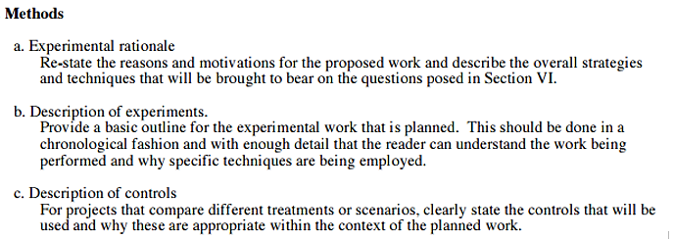
- do not include results and discussion of results here
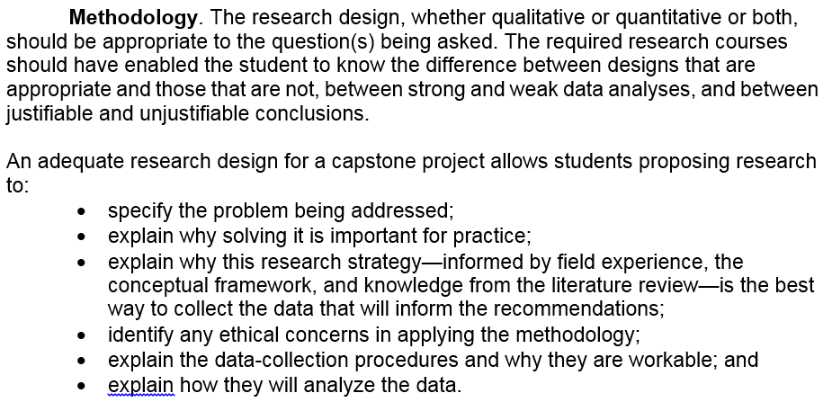

Preliminary results and discussion
- present any results you already have obtained
- discuss how they fit in the framework of your thesis
Work plan including time table
- describe in detail what you plan to do until completion of your senior thesis project
- list the stages of your project in a table format
- indicate deadlines you have set for completing each stage of the project, including any work you have already completed
- discuss any particular challenges that need to be overcome
- create a Gantt chart for the period of your study
Implications of Research
- what new knowledge will the proposed project produce that we do not already know?
- why is it worth knowing, what are the major implications?
List of references
- cite all ideas, concepts, text, data that are not your own
- if you make a statement, back it up with your own data or a reference
- all references cited in the text must be listed
- cite single-author references by the surname of the author (followed by date of the publication in parenthesis)
  - ... according to Hays (1994)
  - ... population growth is one of the greatest environmental concerns facing future generations (Hays, 1994).
- cite double-author references by the surnames of both authors (followed by date of the publication in parenthesis)
  - e.g. Simpson and Hays (1994)
- cite more than double-author references by the surname of the first author followed by et al. and then the date of the publication
  - e.g. Pfirman, Simpson and Hays would be:
  - Pfirman et al. (1994)
- cite newspaper articles using the newspaper name and date, e.g.
  - ....this problem was also recently discussed in the press (New York Times, 1/15/00)
- do not use footnotes
- list all references cited in the text in alphabetical order using the following format for different types of material:
  - Hunt, S. (1966) Carbohydrate and amino acid composition of the egg capsules of the whelk. Nature, 210, 436-437.
  - National Oceanic and Atmospheric Administration (1997) Commonly asked questions about ozone. http://www.noaa.gov/public-affairs/grounders/ozo1.html, 9/27/97.
  - Pfirman, S.L., M. Stute, H.J. Simpson, and J. Hays (1996) Undergraduate research at Barnard and Columbia, Journal of Research, 11, 213-214.
  - Pechenik, J.A. (1987) A short guide to writing about biology. Harper Collins Publishers, New York, 194pp.
  - Pitelka, D.R., and F.M. Child (1964) Review of ciliary structure and function. In: Biochemistry and Physiology of Protozoa, Vol. 3 (S.H. Hutner, editor), Academic Press, New York, 131-198.
  - Sambrotto, R. (1997) lecture notes, Environmental Data Analysis, Barnard College, Oct 2, 1997.
  - Stute, M., J.F. Clark, P. Schlosser, W.S. Broecker, and G. Bonani (1995) A high altitude continental paleotemperature record derived from noble gases dissolved in groundwater from the San Juan Basin, New Mexico. Quat. Res., 43, 209-220.
  - New York Times (1/15/00) PCBs in the Hudson still an issue, A2.
- it is acceptable to put the initials of the individual authors behind their last names, e.g. Pfirman, S.L., Stute, M., Simpson, H.J., and Hays, J (1996) Undergraduate research at ......

III. Order in which to write the proposal
. Proceed in the following order:
- Make an outline of your thesis proposal before you start writing
- Prepare figures and tables
- Figure captions
- Methods
- Discussion of your data
- Inferences from your data
- Introduction
- Abstract
- Bibliography
This order may seem backwards. However, it is difficult to write an abstract until you know your most important results. Sometimes, it is possible to write the introduction first. Most often the introduction should be written next to last.

IV. Tips

Figures
- "Pictures say more than a thousand words!" Figures serve to illustrate important aspects of the background material, sample data, and analysis techniques.
- A well-chosen and well labeled figure can reduce text length, and improve proposal clarity. Proposals often contain figures from other articles. These can be appropriate, but you should consider modifying them if the modifications will improve your point.
- The whole process of making a drawing is important for two reasons. First, it clarifies your thinking. If you don’t understand the process, you can’t draw it. Second, good drawings are very valuable. Other scientists will understand your paper better if you can make a drawing of your ideas. A co-author of mine has advised me: make figures that other people will want to steal. They will cite your paper because they want to use your figure in their paper.
- Make cartoons using a scientific drawing program. Depending upon the subject of your paper, a cartoon might incorporate the following:
  - a picture of the scientific equipment that you are using and an explanation of how it works;
  - a drawing of a cycle showing steps, feedback loops, and bifurcations: this can include chemical or mathematical equations;
  - a flow chart showing the steps in a process and the possible causes and consequences.
- Incorporate graphs in the text or on separated sheets inserted in the thesis proposal
- Modern computer technology such as scanners and drafting programs are available in the department to help you create or modify pictures.

Grammar/spelling
- Poor grammar and spelling distract from the content of the proposal. The reader focuses on the grammar and spelling problems and misses keys points made in the text. Modern word processing programs have grammar and spell checkers. Use them.
- Read your proposal aloud - then have a friend read it aloud. If your sentences seem too long, make two or three sentences instead of one. Try to write the same way that you speak when you are explaining a concept. Most people speak more clearly than they write.
- You should have read your proposal over at least 5 times before handing it in
- Simple wording is generally better
- If you get comments from others that seem completely irrelevant to you, your paper is not written clearly enough never use a complex word if a simpler word will do

V. Resources/Acknowlegements
The Columbia University senior seminar website has a very detailed document on "How to write a thesis" which you might want to look at. Most of the tips given there are relevant for your thesis proposal as well.
Recommended books on scientific writing
Some of the material on this page was adapted from:
http://www.geo.utep.edu/Grad_Info/prop_guide.html
http://www.hartwick.edu/anthropology/proposal.htm
http://csdl.ics.hawaii.edu/FAQ/FAQ/thesis-proposal.html
http://www.butler.edu/honors/PropsTheses.html

