Mr. F’s
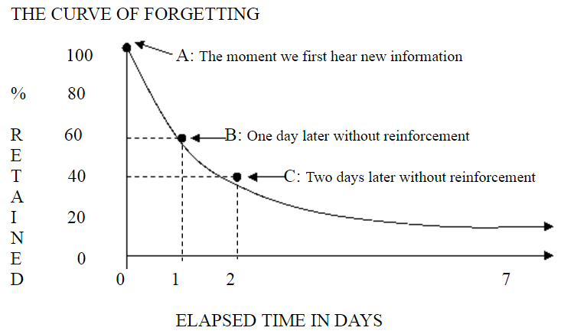
in ECE Courses with Active Learning
Goal: reduce the loss of important information.
How do I do this? Simple, active learning

The numbers: If we do not repeatedly return our attention to these terms and definitions, we will forget about 40% over the first 24 hours (Point B). If we wait another 24 hours before reviewing the information, we have lost 60% (Point C). So we can go from a grade of ‘A’ (100%) to ‘D’ (60%), to ‘F’ (40%) in just 48 hours.

The deception of temporary memory: When we first hear something, because we can immediately think about it and repeat it, we assume we will remember it from then on. However, what has really happened is that our brains have attached a drop of temporary memory “glue” to the information. (There really is a scientific name for the chemicals that bind the memory).

In a short time, this drop of temporary “glue” loses its bond and we forget the information. But if we continually return our mind’s attention to this information, if we continually add more drops of “glue,” eventually the information will become part of more permanent memory.

We add new drops of “glue” by first getting to the new information as soon as we can after we first hear or read it. Then occasionally but continually we review the material, often quizzing ourselves on it. Our study goal is to “touch” the information often, in little review sessions, with a bit of time in between sessions.

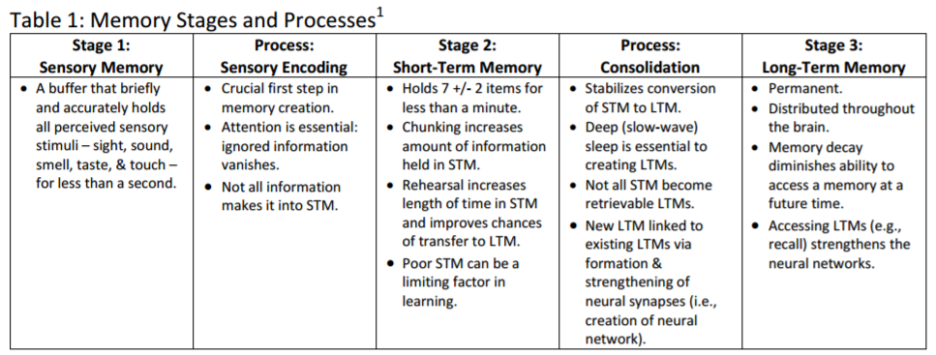

Mr. F’s General Keys to Effective Study
ONE: Remember that the purpose of all studying is to keep The Curve of Forgetting from affecting your recall and ability to use what you have learned.
TWO: The more times you touch new information, the less The Curve of Forgetting will affect it. Eventually, if you touch the new information enough times, it will become part of your LTM.
THREE: Always study in Question/Answer format. In other words, whether you are reading a textbook chapter or going over your lecture notes, you should always be looking for an answer to a question you have created to focus your attention. Stating the obvi…this is also the format of a test!! Studying in this format means that you immediately begin learning the information in the way a test will ask it. Remember--it is possible to learn the right information in the wrong way and fail a test.
FOUR: Create and use FLASHCARDS whenever possible: Put any information you can on flashcards--term or question on the front of the card with the definition or answer on the back. Flashcards are very portable--you can take them with you everywhere and use those 5 to 10 minute free periods in each day to quiz yourself.
FIVE: The very best way (perhaps the only way) to learn anything well is to trickle it in to your mind in little bites or brief intervals over a period of time. Keep in mind that this method is the opposite of cramming where you try to absorb large amounts of information in one or two long sessions. Cramming is the least effective study method because The Curve of Forgetting will immediately begin to erase the information from your memory.
So, how do I engage in active learning? Simple, make taking notes an active, not passive, process.
There are four stages to good note taking:
1. Note taking , 2. Note making, 3. Note interacting, 4. Note reflecting

I. NOTE TAKING – CORNELL NOTES FORMAT… there is no good substitute.
• Prepare a page to take notes the same way each time. An essential question at the top of the page focuses the learner on the key learning objective that they should be able to discuss upon leaving the class
• Rule the page into two columns, with the first column taking up about a third of the page. The space on the left is for questions and notes that may be added in later as students reflect on their notes. The space on the right is for notes from the lecture, textbook, laboratory experiment, video, audio, whatever the source
• Listen and take notes in your own words – paraphrase what’s heard so it makes sense, rather than write down verbatim what’s heard/seen
• Leave spaces and lines between main ideas for revising later and adding information
• Develop your own consistent system of abbreviations and symbols to save time as you take notes
• Write in phrases, not complete sentences
• Use bullet points and lists where possible
• Learn how to listen for important information versus trivial information
• Take cues from the lecturer or source, e.g. “This is important…”
• Use highlighters and color to indicate key ideas, changes in concepts or links between information.
II. NOTE MAKING
• Review and revise the content of your notes
• Write questions in the left-hand side near where the answer is contained on the right-hand side
• Connect key chunks of material in the notes pages using color or symbols if it helps
• Exchange ideas and collaborate with other students
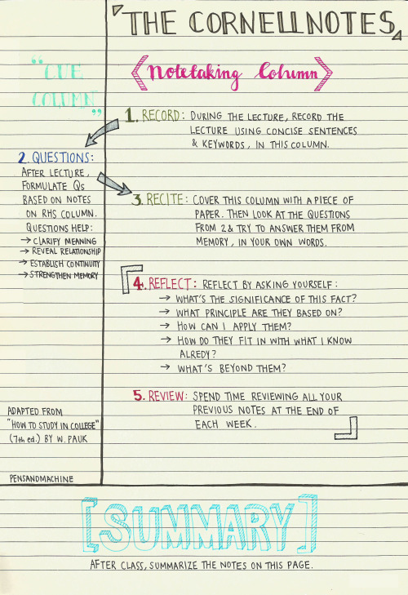
III. NOTE INTERACTING
• Link all the learning together by writing a summary at the end of that day’s notes that addresses the essential question and answers the questions from the left margin. Note: a summary is different from a reflection that focuses on your response to the learning task or content
• Learn from their notes by building in to their study timetable regular times for revising their notes for each subject
• Cover the information on the right-hand side and use the questions as study prompts before a test.
IV. NOTE REFLECTING
• Feedback should be sought from a peer or teacher to check for your understanding of the process in the initial learning phase before you become more comfortable with active learning.
• Students should address the feedback by focusing on one area of challenge they are experiencing in their learning
• Students should also reflect over an entire unit after an exam to assess how well they actively studied for that exam.

