Mutations Virtual Lab
Directions: Navigate to the website below and follow the steps indicated below to go through the mutations simulation to gain experience with errors in the genetic code and how it changes the expression of the gene through protein synthesis. Once complete, answer the questions below thoroughly.
What you are responsible for: knowing the physical process of how a mutation forms, what a mutation is and how it can effect an organism, and the different types of mutations (see mutation guide in section VI for this).
http://www.mhhe.com/biosci/genbio/virtual_labs/BL_26/BL_26.html

I. Introduction:
Mutations involve a physical change to genetic material that results in the abnormal encoding of protein sequences. The impact of these changes can be insignificant to the extreme of devastating.
In this lab, you will complete mRNA and protein sequences based on the information provided. You will be given a starting mRNA sequence, its associated amino acids, and a mutation rule. Use these to construct a new mRNA sequence. Compare the original and mutated sequences to see the impact of the mutation.
The mutation guide contains information on various types of mutations and their impact.

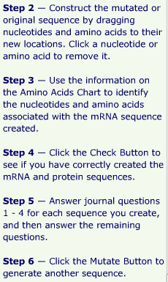
II. Procedures:
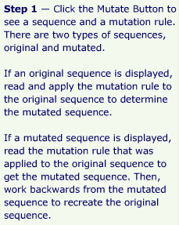
III. Virtual Lab Questions:
1. Describe the differences between the original and mutated sequences.

2. How many amino acids were changed?
3. What do you think will be the impact of this mutation? Why?

4. Was the sequence a result of point or frameshift mutation?

5. Explain why all mutations are not necessarily harmful.

6. Does changing the sequence of nucleotides always result in a different amino acid sequence? Explain.
IV. Mutation Guide:
