Name _______________________________
Modeling Mitosis with Beads
In this activity, you will “act” out the phases of mitosis using pop bead chromosomes. While this activity may seem very straightforward, it is an excellent opportunity to work on mastering the vocabulary that accompanies this topic.
Materials
• bag of red and yellow pop beads (individual beads = genes that code for traits, proteins, in living organisms)
• magnetic centromeres (thin, soft tubes containing a magnet = thinner regions where chromosomes bind)
• chalk pen to draw cell membranes on tables (get from Mr. F when you’re ready)
• string (to simulate the spindle fibers that pull chromosomes to opposite poles of cell)
• Centrosome (short empty tube section that spindle fibers anchor to and actively tugs on the spindle fibers)
• Chromosome simulation directions in “Student Guide”.
Procedure
1. This activity works best in pairs (or in groups of three, max.). You are welcome to work alone if you wish.
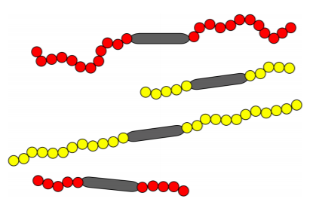
2. Begin by building four chromosomes out of pop beads. I recommend that you build two long chromosomes and two short chromosomes, so that they look something like this:
It’s not necessary to have exactly the same number of beads as the picture. Just make sure you have four chromosomes, two red and two yellow, two long and two short.
3. Place the 4 chromosomes (2 from each parent) in the middle of your workspace on the lab bench and draw a nuclear envelope around them and a larger cell membrane around that.
4. You will now begin the process of modeling the steps of mitosis. To do this, you will use the “Student Guide” that comes with each set of pop beads.
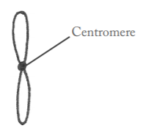
Mitosis Instructions
In general, students find moving the chromosomes around helps them understand the phases of mitosis, but there are several steps that may trip you up. You are beginning this activity with four un-replicated chromosomes, illustrated like this for simplicity.
During DNA replication, the chromosomes become copied to look like this.
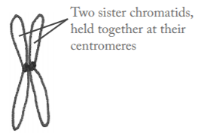
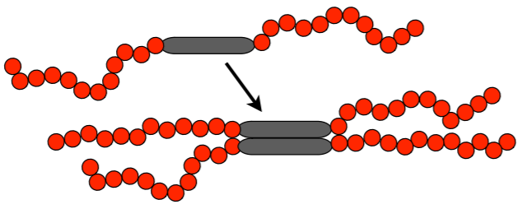
This is how you should do this with the bead chromosomes (only one is shown below, do this for all four):
Student Response Sheet
Directions: Draw and color your chromosomes in the table below. Using the resources we used before spring break, as well as the student guide for this activity, fill in what key events happen during each phase. Include ALL key structures labeled within your drawings.
Phase drawing (remember to include a nuclear envelope (when present) and a cell membrane) | Events that occur during this phase
Interphase

Prophase

Metaphase

Anaphase

Telophase

BONUS… Unknown phase I.D. set up by Mr. F: Station 1 shows ____________________, Station 2 shows _________________________, & Station 3 shows ___________________________.

