Name:_______________________________________
Random Sampling
Scientists cannot possibly count every organism in a population. One way to estimate the size of a population is to collect data by taking random samples. In this activity, you will look at how data obtained from random sampling compare with data obtained by an actual count.
Procedure:
1. Tear a sheet of paper into 20 slips, each approximately 4cm x 4 cm.
2. Number 10 of the slips from 1 to 10 and put them in a small container
3. Label the remaining 10 slips from A through J and put them in a second container.
The grid shown below represents a meadow measuring 10 m on each side. Each grid segment is 1m x 1m. Each black circle represents one sunflower plant.
4. Randomly remove one slip from each container. Write down the number-letter combination and find the grid segment that matches the combination. Count the number of sunflower plants in that grid segment. Repeat and fill out data table. Include totals and averages.

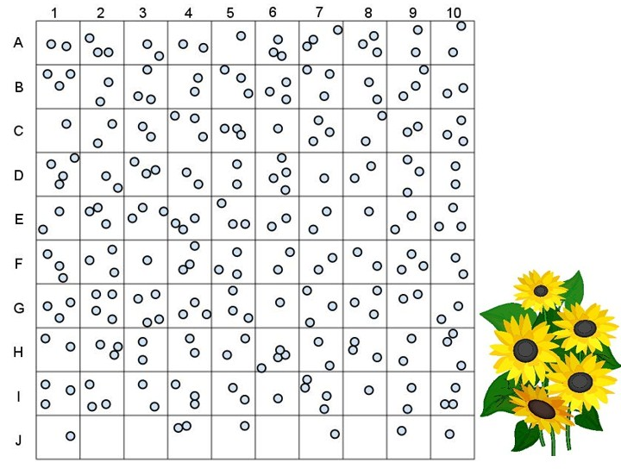

5. Repeat step 4 until you have data for 10 different grid segments (record data in table 1). These 10 grid segments represent a sample. Gathering data from a randomly selected part of a larger area is called sampling.
6a. Find the total number of sunflower plants for the 10-segment sample. This is an estimation based on a formula. Add all the grid segment sunflowers together and divide by ten to get an average number of sunflower plants per grid segment. Record this number in the table.

6b. Multiply the average number of sunflower plants by 100 (this is the total number of grid segments) to find an estimate of the total number of plants in the meadow. Record this number in your data table.

7. Now count all the sunflower plants shown in the meadow. Record this number in the data table. Divide this figure by 100 to calculate the average number of sunflower plants per each grid.

TABLE 1: Sunflower Random Sampling Data

Random Sampling Data (steps 4 & 5)
Grid Segment  (number-letter of quadrat) | Number of Sunflowers counted in quadrat | Actual Data (step 7)
Total number of Sunflowers** ______
(count by hand)

Average number of Sunflowers
(divide total by 100) Per grid _____

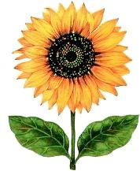

Total Number of
Sunflowers (step 6a)
Average per each grid
(divide total by 10) (step 6a)
Total number of plants in meadow*
(multiply average by 100) (step 6b)

Analysis:
1. Compare the total number you got for sunflowers from the SAMPLING (your 10 randomly chosen quadrats) to the ACTUAL count. How close are they?

2. Why was the paper-slip method used to select the grid segments?

3. Percent error. Error in our estimates always exists and it can be mathematically calculated by using the following formula: % error = [(your estimate* – actual value**) / actual value**] x 100. Calculate the percent error below.

3a. A lazy ecologist collects data from the same field, but he stops just on the side of the road and just counts the 10 segments near the road. These 10 segments are located at J 1-10. When he submits his report, how many sunflowers will he estimate are in the field?

3b. Suggest a reason why his estimation differs from your estimation.

4. Population Sampling is usually more effective when the population has an even dispersion pattern. Clumped dispersion patterns are the least effective. Explain why this would be the case.

5. Describe how you would use sampling to determine the population of dandelions in a nearby park.

 | 7
 |  |  |  | 3
 |  |  | 5
11 |  | 9
6. In a forest that measures 5 miles by 5 miles, a sample was taken to count the number of silver maple trees in the forest. The number of trees counted in the grid is shown to the right. The grids where the survey was taken were chosen randomly. Determine how many silver maple trees are in this forest using the random sampling technique. Show your work!

Practice Scenario for Analysis:
A technique called sampling can be used to estimate population size. In this procedure, the organisms in a few small areas are counted and projected to the entire area. For instance, if a biologist counts 10 squirrels living in a 200-square foot area, she could predict that there are 100 squirrels living in a 2000 square foot area. This is a simple ratio.
2. A biologist collected 50 liters of pond water and counted 10 mosquito larvae. How many larvae would you estimate to be in that pond if the total volume of water in the pond was 80,000 liters? Show work.

3. What are some problems with this technique? What could affect its accuracy?

