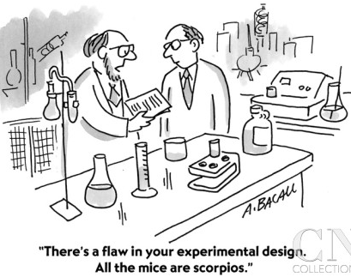
Name

Weekend Homework – Scientific Method
Directions: Below you will find some aspect of the scientific method (summary, question, purpose, and/or hypothesis) and you are to design an experiment and fill in the missing fields given the information provided. Place your cursor just after the “:” and type your answer and allow the lines to bump down as you add to the page. Save to your Google drive (Fluids folder) when completed.
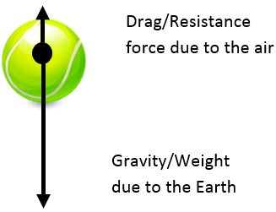
Scenario One: Mr. F wants to test the effect of air resistance on different objects in free fall in order to determine which strikes the ground first. He has a ping pong ball, tennis ball, lacrosse ball, beach ball, and bowling ball. What is the:
1. Scientific question:
2. Hypothesis:
3. Independent variable:
4. Dependent variable:
5. Control:

Scenario Two: An eager scientist wants to clean up an oil spill in the Gulf of Mexico. He designs a way to do so using magnetically charged graphite powder that he will cast over the oil on the surface of the water. He will then use different sized and intensities of magnets to test how much oil is collected using this method.
6. Scientific question:
7. Hypothesis:
8. Independent variable:
9. Dependent variable:
10. Control (this may be challenging but give it a try!!):

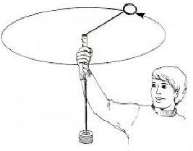
Scenario Three: A physics student wants to learn about circular motion by revolving a mass on a string over their head. They become curious if the revolving object’s speed changes if it is heavy or light. Five different masses are used (25g, 50g, 100g, 150g, 200g) and are revolved overhead with the same force. It was easy for them to measure the speed of the object from the data taken.
11. Scientific purpose:
12. Hypothesis:
13. Independent variable:
14. Dependent variable:
15. Control (this may be challenging but give it a try!!):

Scenario Four: YOUR CHOICE!! Summarize a scenario of your choosing, any science. Once summarized, fill in the fields below.
Summary:
16. Scientific purpose:
17. Hypothesis:
18. Independent variable:
19. Dependent variable:
20. Control:

