**Scientific Method - Controls and Variables**

***Definition of Key Terms***

* ***Control*** - A part of than experiment that is not changed so it can be compared to the experimental variables.
* ***Variable*** - Any part of an experiment that can be changed, or manipulated by the scientist.
* ***Independent Variable*** – The variable of the experiment that is changed, or manipulated by the scientist or person performing the experiment.
* ***Dependent Variable*** - The part of the experiment that is affected by the independent variable. Also called the responding variable as it responds to the change made by the scientist. This is the variable that is measured. Also compared to the control to see how large the change is.

***SpongeBob and his Bikini Bottom pals have been busy doing a little research. Read the description for each experiment and answer the questions that follows each scenario. Circle the most correct answer.***

***Scenario 1: Krusty Krabs Breath Mints***

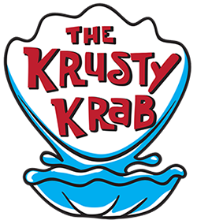Mr. Krabs created a secret ingredient for a breath mint that he thinks will “cure” the bad breath people get from eating crabby patties at the Krusty Krab. He asked 100 customers with a history of bad breath to try his new breath mint. He had fifty customers (Group A) eat a breath mint after they finished eating a crabby patty. The other fifty (Group B) also received a breath mint after they finished the sandwich; however, it was just a regular breath mint and did not have the secret ingredient. Both groups were told that they were getting the breath mint that would cure their bad breath. Two hours after eating the crabby patties, thirty customers in Group A and ten customers in Group B reported having better breath than they normally had after eating crabby patties.

1. Which people are in the control group?

a. Group A b. Group B

2. What is the variable?

a. The actual breath mint. c. The secret ingredient in the breath mint.

b. The crabby patties. d. How many crabby patties eaten.

3. What should Mr. Krabs’ conclusion be?

a. The breath mint with the secret ingredient does reduce breath odor.

b. The breath mint with the secret ingredient reduces breath odor over 50% of

the time.

c. The breath works, but it is not 100% effective.

d. All of the above.

***Scenario 2: SpongeBob Clean Pants***

SpongeBob noticed that his favorite pants were not as clean as they used to be. His friend Sandy told him that he should try using Clean-O detergent, a new laundry soap she found at Sail-Mart.

SpongeBob made sure to wash one pair of pants in plain water and another pair in water with the Clean-O detergent. After washing both pairs of pants a total of three times, the pants washed in the Clean-O detergent did not appear to be any cleaner than the pants washed in plain water.

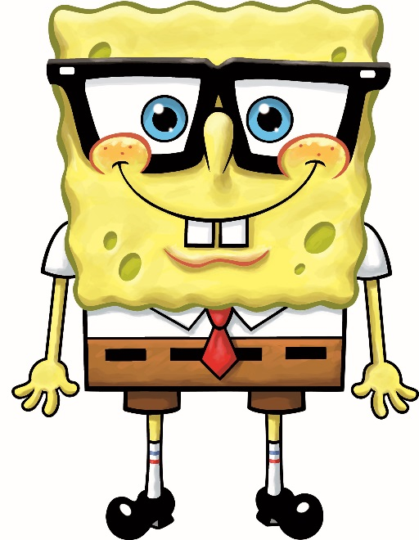4. What was the problem SpongeBob wanted to investigate?

a. Is Clean-O detergent effective?

b. Is the length of time the pants are washed important?

c. How does water temperature affect cleaning pants?

d. Does how often I wash my pants affect how clean they are?

5. What is the variable?

a. Water temperature. c. Laundry soap

b. Length of wash time. d. Size of washing tub.

6. What should Sponge Bob’s conclusion be?

a. Clean-O best cleans his pants.

b. Plain water best cleans his pants.

c. Cold water best cleans his pants.

d. Clean-O is not effective cleaning his pants.

***Scenario 3: Squidward’s Symphony***

|  |  |  |  |  |
| --- | --- | --- | --- | --- |
| ***Number of Jellyfish/Instrument*** | | | | |
| ***Trial*** | ***No Music*** | ***Clarinet*** | ***Flute*** | ***Guitar*** |
| 1 | 5 | 15 | 5 | 12 |
| 2 | 3 | 10 | 8 | 18 |
| 3 | 2 | 12 | 9 | 7 |

Squidward loves playing his clarinet and believes it attracts more jellyfish than any other instrument he has played. In order to test his hypothesis, Squidward played a song on his clarinet for a total of 5 minutes and counted the number of jellyfish he saw in his front yard. He played the song a total of three times on his clarinet and repeated the experiment using a flute and a guitar. He also recorded the number of jellyfish he observed when he was not playing an instrument. The results are shown in the chart.

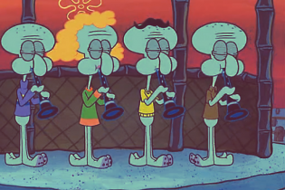7. What is the variable?

a. Number of jellyfish. c. Length the music was played.

b. Instrument. d. The song he played.

8. What should Squidward’s conclusion be?

a. The clarinet and guitar attracted the same number of jellyfish.

b. The flute attracted more fish than the control (no music).

c. Music attracts more jellyfish than does no music.

d. All of the above.

***Scenario 4: Super Bubbles***

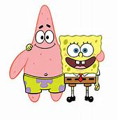

Patrick and SpongeBob love to blow bubbles! Patrick found some Super Bubble Soap at Sail-Mart. The ads claim that Super Bubble Soap will produce bubbles that are twice as big as bubbles made with regular bubble soap. Patrick and SpongeBob made up two samples of bubble solution. One sample was made with 5 oz. of Super Bubble Soap and 5 oz. of water, while the other was made with the same amount of water and 5 oz. of regular bubble soap. Patrick and SpongeBob used their favorite bubble wands to blow 10 different bubbles and did their best to measure the diameter of each one. The results are shown in the chart

|  |  |  |
| --- | --- | --- |
| ***Bubbles***  **(Diameter in centimeters)** | | |
| ***Bubble*** | ***Super Bubble*** | ***Regular Soap*** |
| 1 | 15 | 10 |
| 2 | 10 | 5 |
| 3 | 12 | 16 |
| 4 | 18 | 14 |
| 5 | 22 | 11 |
| 6 | 13 | 12 |
| 7 | 16 | 11 |
| 8 | 18 | 15 |
| 9 | 15 | 15 |
| 10 | 12 | 6 |

9. What did the Super Bubble ads claim?

a. Super Bubble produces bubbles twice as large as regular bubble soap.

b. Super Bubble makes twice as many bubbles as regular bubble soap.

c. Super Bubble bubbles last twice as long as bubbles made using regular bubble soap.

d. Super Bubble is cheaper than regular bubble soap.

10. What is the variable?

a. Bubble size.

b. Number of bubbles made.

c. Length of time bubbles last.

d. Type of bubble solution.

11. What should their conclusion be?

a. Super Bubble solution did not produce bubbles twice as large as those made

with regular bubble soap.

b. Regular bubble soap lasts twice as long as Super Bubble.

c. Bubbles made with Super Bubble last twice as long as bubbles made with regular bubble soap.

d. There was no difference between Super Bubble and regular bubble soap.

***Scenario 5: Slimotosis***

Sponge Bob notices that his pal Gary is suffering from slimotosis, which occurs when the shell develops a nasty slime and gives off a horrible odor. His friend Patrick tells him that rubbing seaweed on the shell is the perfect cure, while Sandy says that drinking Dr. Kelp will be a better cure. Sponge Bob decides to test this cure by rubbing Gary with seaweed for 1 week and having him drink Dr. Kelp. After a week of treatment, the slime is gone and Gary’s shell smells better.

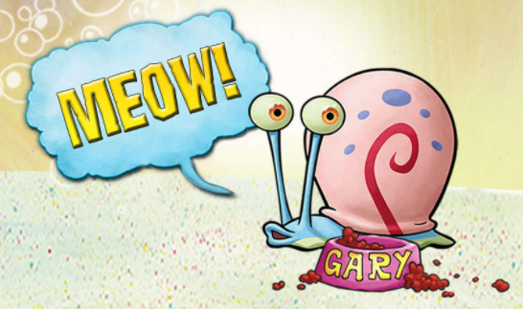12. What was the initial observation?

a. Gary’s shell is dull in color and hard to see.

b. Gary’s shell is glowing in the dark.

c. Gary’s shell has a nasty slime and gives off a horrible odor.

d. Gary’s shell is developing holes in it.

13. What is the variable?

a. Rubbing seaweed on the shell. c. Both a and b.

b. Drinking Dr. Kelp.

14. What should Sponge Bob’s conclusion be?

a. Rubbing seaweed cured the slimotosis.

b. Drinking Dr. Kelp cured the slimotosis.

c. Both rubbing seaweed and drinking Dr. Kelp cured the slimotosis.

d. We cannot determine which cured the slimotosis. The experiment must be re-

done, testing one variable at a time.

**Key Vocabulary**

***Analyze*** – Examine data collected in an experiment to determine what it means.

***Conclude*** – Reach a decision based on the analysis of data.

***Data*** – Information collected during an experiment.

***Experiment*** – A test that is done to determine if a hypothesis is correct or not.

***Hypothesis*** – Your proposed answer to the question or solution to the problem.

***Inference (Infer)*** – Coming to a conclusion based on your existing knowledge. (Example – seeing a student wearing a sports team jersey and concluding the student likes that team.)

***Observe*** – Watch something carefully and record what you see, hear, touch, smell, and/or taste.

***Qualitative data*** – Data dealing with descriptions; data is observed (colors, textures, smells, tastes, appearance, beauty, etc.).

***Quantitative data*** – Data which can be measured (length, height, area, volume, weight, speed, time, temperature, etc.).

***Results*** – Outcome of an experiment.

***Tentative*** – Basic results that may or may not be accurate; or may need further testing.

***Variable*** – Something that can be changed.



***Across***

3. Reach a decision based on the analysis of data.

10. Data which can be measured (length, height, area, volume, weight, speed, time, temperature, etc.).

11. A test that is done to determine if a hypothesis is correct or not.

12. Watch something carefully.

***Down***

1. Data dealing with descriptions; data is observed (colors, textures, smells, tastes, appearance, beauty, etc.).

2. Basic results that may or may not be accurate; or may need further testing.

4. Your proposed answer to the question or solution to the problem.

5. Outcome of an experiment.

6. Arriving at a conclusion based on your existing knowledge. (Example, seeing a student wearing a sports team jersey and concluding the student likes that team.)

7. Examine data collected in an experiment to determine what it means.

8. Information collected during an experiment.

9. Something that can be changed.

***Word Bank***: ***Each word is only used once.***

Analyze, Conclude, Data, Experiment, Hypothesis, Inference, Observe, Qualitative data, Quantitative data, Results, Tentative, Variable