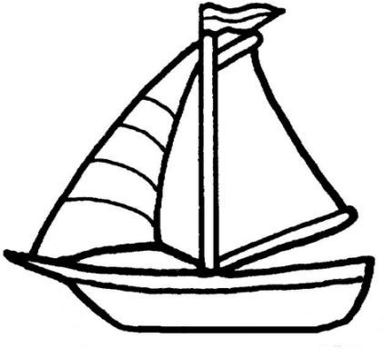
Name:_____________________________________ Date:_________________
Your Partner’s Name:_____________________________________ Per:_______

Marine Biology - Sink or Float?
Phenomenon - How does this float?

Activity 1 - Sink and Float

Question: How can the same object sink and float?
- Record your initial thoughts to the question above in your notebook.

Procedure:
- Measure 30 grams of modeling clay and roll into a ball.
- Place ball of clay in bin filled with water and make observations.
- Using the same 30 gram piece of modeling clay change the shape so that it will float on the surface.

- Record observations from this activity, including design drawings.

- What conclusions/inferences can you draw from this activity? Why was an object made of the same material able to both sink and float?

- How do marine organisms float? Provide an example.

Activity 2 - The Great Boat Design Challenge

Think about the many uses we have for boats. There are many different boat designs depending on the function of the boat.

Challenge: Design a boat to hold as much weight as possible yet still be cost efficient to build using the materials listed below. You must test and edit your design at minimum of three times; however, you need to keep in mind that you only have a $3,000 budget. Use the fields and tables below to draw your boat and tally the running cost for your effort.

Materials:
Lumber (popsicle sticks) = $50 each Metal (aluminum foil) = $25/sheet
Welding Materials (glue) = $50 bottle Reinforcements (plastic straws) = $25 each
Buoys (corks) = $50 each Cable/Rope (masking tape) = $10/inch

Create the following table in your lab notebook and record the following data:

Design 1 Sketch Design 2 Sketch
Lumber (popsicle sticks) = $50 each x ____ = ____
Metal Metal (aluminum foil) = $25/sheet x ____ = ____
Welding Materials (glue) = $50 bottle x ____ = ____
Reinforcements (plastic straws) = $25 each x ____ = ____
Buoys (corks) = $50 each x ____ = ____
Cable/Rope (masking tape) = $10/inch x ____ = ____

Total cost (this build): $ _______________________
Total mass held: _________________________
Running cost for designs 1 & 2: $____________
Lumber (popsicle sticks) = $50 each x ____ = ____
Metal (aluminum foil) = $25/sheet x ____ = ____
Welding Materials (glue) = $50 bottle x ____ = ____
Reinforcements (plastic straws) = $25 each x ____ = ____
Buoys (corks) = $50 each x ____ = ____
Cable/Rope (masking tape) = $10/inch x ____ = ____

Total cost: $ _______________________
Total mass held: _________________________

Design 3 Sketch

- What are some factors you needed to take into consideration when testing your boat? How did they affect the amount of mass your boat was able to hold?

- How would your design differ if the task was to build a boat whose purpose was for oceanographic research?
Lumber (popsicle sticks) = $50 each x ____ = ____
Metal Metal (aluminum foil) = $25/sheet x ____ = ____
Welding Materials (glue) = $50 bottle x ____ = ____
Reinforcements (plastic straws) = $25 each x ____ = ____
Buoys (corks) = $50 each x ____ = ____
Cable/Rope (masking tape) = $10/inch x ____ = ____

Total cost (this build): $ _______________________
Total mass held: _________________________
Running cost all 3 designs: $____________

Activity 3 - Why do things float?
The purpose of this activity is to discover the forces that are acting on an object in a fluid such as water.
Go to the Glencoe forces and fluids online simulation:
Read the background information
Sketch a boat on water. Using arrows indicate and label the forces acting on the boat (free body diagram)
Procedure:
- Find the mass of the object by dragging the object to the digital scale
- Determine the mass of displaced water by the object (1 mL of water = 1 g) and record in your table
- Form a hypothesis based upon this information whether the object will float or sink
- Select the watch what happened and record your observation
Title : ____________________________________________________________________________________
Object | Mass of Object (g) | Mass of Displaced Water (g) | Predication  (Float or Sink? | Observation  (Float or Sink?)
Wood | 13.3 | 15.6 | Float | Float
Aluminum
Plastic
Lead
Cork
Steel
Clay
Rubber
Candle
Reflection Questions:
- Using the information gathered, what factors determine whether an object will float or sink?

- The mass of displaced water is also equal to what?

- What is the role of density when determining whether an object will sink or float?

- Define buoyancy. What is Archimedes principle? (video)

- How have these forces and characteristics been considered when it comes to ocean vessel design? How have these forces contributed to the natural selection for adaptations in different marine organisms?

Still confused? Watch the following tutorial - Buoyancy Overview

