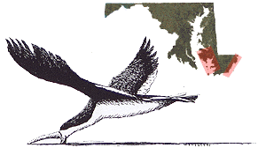
Name

Air Skimmer Reflection (40 points)
Directions: Answer the questions below about the air skimmer data collection activity we conducted this past week. These answers should be detailed, where called for, and use your knowledge of the scientific method in others. As you answer the questions, let the questions below continue to drop down.
1. State a scientific question for the air skimmer activity we just did? (3 points)

2. What is a measureable testable hypothesis for this activity? (3 points)

3. Describe how your skimmer traveled for the first time. State your first observations in detail. (5 points)

4. Describe the difference before and after you applied mass (paper clips) to the front of the skimmer. (5 points)

5. Research what the causes were for your skimmer to “skim” across the floor. What are the physics at play here? Use verbal descriptions mainly, but you can include a diagram to help your explanation. (7.5 points)

6. How far did your skimmer travel (in both centimeters and meters)? Did you think your skimmer would travel further than it did? If so, what do you think caused it to not go as far? Use the design and physics to help you answer this. (4 points)

7. Paste the correct Excel graph below that best shows the results of our trials FOR EACH STUDENT, based off the student results we tabulated (see your handouts). Which students had the 1st, 2nd, and 3rd longest average distances traveled? What was the average distance traveled of every student in the class? (7.5 points)

8. What were the biggest challenges in assembling your skimmer? If you could make another skimmer from scratch, what would you change from the first prototype you made? Why? (3 points)

9. What considerations did you need to take into account when using the launch pad? What things did you have to make sure of when using the launch pad to guarantee a successful launch? (2 points)

