Directions: you will randomly choose one of the 24 bacterial species below to make a “Bacterial Brag Sheet” about. Bacteria are underappreciated and in many cases, made to be the villain. Your job is a bacterial promoter for the Society for Microbiology and your task is to make more people appreciate the amazingness of your little creatures. To do so, you will need to craft a brochure using Microsoft Publisher or MS Word and a brochure template to create this informational. If it’s good (beneficial), then boast about it so people are likely to appreciate them for what they do. If they are bad (pathogenic), convince people of the incredible abilities these little bugs have. You can discuss them as having near “super power” in a way to draw appreciation for their amazingness. It’s a tall order, but you can do it!

What you will need to investigate and brag about these criteria (5 points each adequately bragged about criteria, total = 50 points):
- Gram-positive or gram-negative? What does this mean and why is it called this? What cell structure does this use to determine the category of bacteria?
- How is the bacteria transmitted?
- What is the bacteria’s Genus known for?
- What is this bacteria known for, historically or for extreme cases/outbreaks? Diseases? Symptoms?
- Include a labeled diagram.
- Where do they naturally occur (which environments)?
- What do they do (either to a host or in the environment)? Do they produce some sort of toxin and why? Do they have a protective layering? What structure produces the toxin? ... etc
- Shape? External and internal structures?
- Beneficial? Neutral? Pathenogenic? Deadly? AND WHY?
- What is their shape?

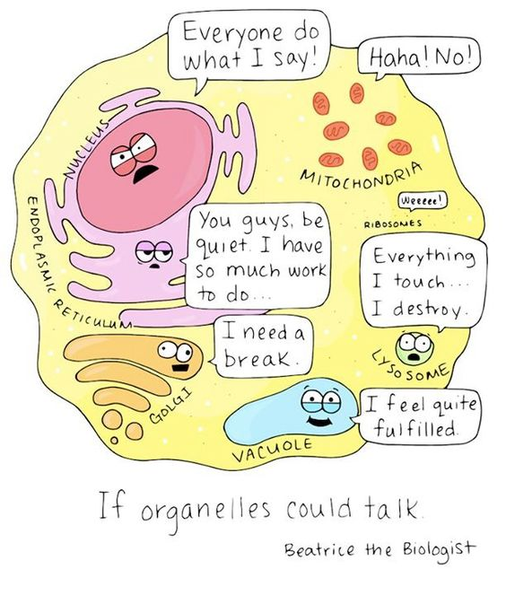
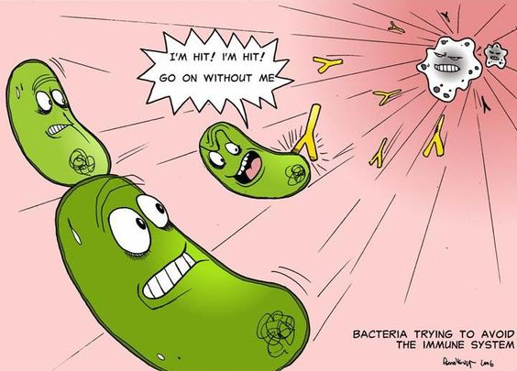
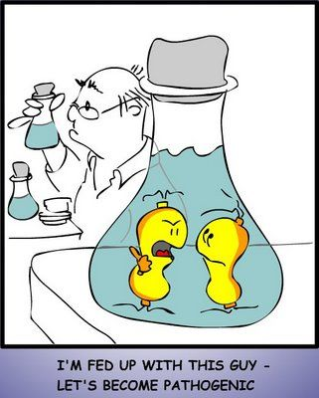

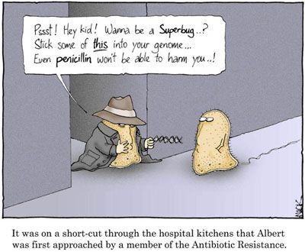
Streptococcus mutans Porphyromonas gingivalis
Mycobacterium tuberculosis Clostridia perfringens
Yersinia pestis Lactobacillus acidophilus
Salmonella enterica Vibrio cholera
Listeria monocytogenes Staphylococcus aureus
Klebsiella pneumonia Brucella melitensis
Streptobacillus moniliformis Salmonella typhi
Neisseria meningitides Bacillus anthrasis
Alcanivorax borkumensis Chlamydia psittaci
Bartonella henselae Burkholderia psuedomallei
Helicobacter pylori Methanopyrus kandleri
Natronomonas pharaonis Rickettsia rickettsii

