Na’am

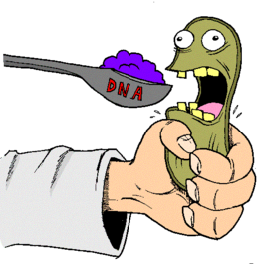
Ampicillin Resistance Transformation of Escherichia coli
The skinny (I mean Introduction…): In this laboratory you will use some basic tools of molecular biology to gain an understanding of some of the principles and techniques of genetic engineering. In the first part of the lab, you will use antibiotic-resistance plasmids to transform Escherichia coli. In the second part, you will use gel electrophoresis to separate fragments of DNA for further analysis.
Directions: answer questions below from the two-part simulation on bacterial transformation. If the copying/pasting of graphics (NOT TEXT) help you utilize this worksheet as a study guide, then incorporate such pictures/graphics into your answers. Save to google drive and share with LFatsy625@gmail.com (note: I KNOW that ECE students can follow directions and distinguish between sharing the document via google docs and attaching the file to an email…one will be graded, the other will receive a zero).
Lab site: http://www.phschool.com/science/biology_place/labbench/lab6/intro.html

PART ONE: TRANSFORMATION
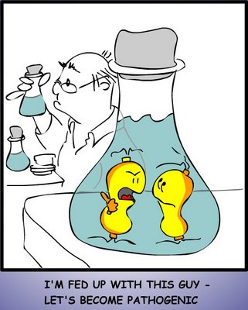
1. Describe the following:
Transformation –
Ampicillin –
Ampicillin resistance –
Plasmid –
-amp^{R} –
+amp^{R} –

2. Describe the E. coli growth curve including the knowledge you already have on the cell cycle. The length of each major phase depends on what factor?

3. Detail the six steps in transforming your E. coli sample. Both what physical steps are used AND the reason for them.

4. What is your prediction for how -amp^{R} E. coli will grow on growth plates with and without ampicillin present? How about +amp^{R} ?

5. Should transformation be a success, copy and paste the Labeling the Results of Your Experiment validated answers below with the correct/incorrect indications for each.

PART TWO: ELECTROPHORESIS
6. How are restriction enzymes (aka restriction endonucleases) related to recognition sequences? Describe the restriction endonuclease used in this electrophoresis simulation?

7. Communicate clearly what is meant by a recognition site being “palindromic”.
8. What is missing when the restriction endonuclease “Smal” is employed?

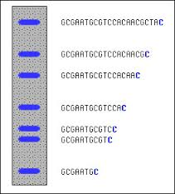
9. Describe why you might see the following results on the dyed agarose gel to the right. Which end of the gel would located nearest to the positive terminal of the electrophoresis apparatus and which end next to the negative terminal?

10. What are the major steps involved with an electrophoresis testing? Describe in detail how each individual step is conducted.

11. If methylene blue dye is not utilized, what is the obstacle to this process?

12. What is the usefulness of adding a known sequence to one of the wells of the agarose gel?

13. What can you say about HindIII ("Hin D Three")?

14. Watch the 6-minute tutorial on how to generate a DNA Ladder Standard Curve to create a curve based on the data in the simulation. You will need MS Excel opened to complete. Insert/paste the log graph below of all DNA sections.

15. Test yourself by honestly taking the lab quiz (after you’ve digested the information fully) and report your score below (again be honest) as you’ll never know what you need to brush up on if you do not do so…

Mr. F, My seriously honest, no joke, no cheating, Honest Abe score is a correct out of 8 questions.
I need to brush up on the following topics that I didn’t get correct on the quiz (list below):

